
WRAPTURE: AI-POWERED SUSTAINABLE PACKAGING RECOMMENDATION SYSTEM

FINAL YEAR

PROJECT PHASE – I REPORT

Submitted by
CHATHURVITHA S K - 23619232 REYSHMASHRI J - 23619226 THASLEEM SAFEEQ M - 23619237

in partial fulfilment of the requirements for the award of the degree of

BACHELOR OF TECHNOLOGY CSE IN
ARTIFICIAL INTELLIGENCE AND MACHINE LEARNING

DEPARTMENT OF ARTIFICIAL INTELLIGENCE AND MACHINE LEARNING
SCHOOL OF ENGINEERING

VELS INSTITUTE OF SCIENCE, TECHNOLOGY & ADVANCED STUDIES (VISTAS)

CHENNAI – 600 117
OCTOBER 2026

BONAFIDE CERTIFICATE

Certified that this project report "WRAPTURE: AI-POWERED SUSTAINABLE PACKAGING RECOMMENDATION SYSTEM" is the bonafide work of REYSHMASHRI J, THASLEEM SAFEEQ M, and CHATHURVITHA S K, who carried out the project under my supervision. Certified further that, to the best of my knowledge, the work reported here does not form part of any other project report or dissertation on the basis of which a degree or award was conferred earlier on this or any other candidate.

SIGNATURE OF THE HOD  Dr. K. Ulaga Priya, M.E., Ph.D.  Associate Professor & Head  Department of AI&ML  School of Engineering  VISTAS  Chennai - 600117 | SIGNATURE OF THE SUPERVISOR  Dr. K. Ulaga Priya, M.E., Ph.D.  Associate Professor & Head  Department of AI&ML  School of Engineering  VISTAS  Chennai - 600117

Submitted for the Project Work and Viva-Voce examination held on …………………. at Vels Institute of Science, Technology and Advanced Studies (VISTAS), Chennai – 600 117.

INTERNAL EXAMINER EXTERNAL EXAMINER

ACKNOWLEDGEMENT

It is certainly a great delight and proud privilege to acknowledge the help and support I received from the positive minds around me in making this venture a successful one. The infrastructural support with all kinds of lab facilities have been a motivating factor in this completion of project work, all because of FOUNDER & CHAIRMAN, Shri. Dr. ISHARI K. GANESH., with great pleasure that I take this opportunity to thank him. I am grateful to our HEAD OF THE DEPARTMENT, Dr. K. Ulaga Priya, M.E., Ph.D, for her continuous support for the project, from initial advice and contacts in the early stages of conceptual inception, and through on-going advice and encouragement to this day. I extend our warmest thanks to my INTERNAL GUIDE, Dr. K. Ulaga Priya, M.E., Ph.D, who has patiently guided and provided us with invaluable advice and help. I am thankful to my Project Coordinator Ms.S.M.Sowmiya, M.E., (Ph.D)I would like to express my greatest gratitude to our Staff members, Librarian, and Non-teaching staff members of Computer Centre, who have helped and supported me throughout. Last but not the Least, I wish to thank my parents and my friends for their individual support and interest who has inspired me and encouraged me to go in my own way, without them I would be unable to complete this project.

CHATHURVITHA S K – 23619232
REYSHMASHRI J – 23619226
THASLEEM SAFEEQ M – 23619237

TABLE OF CONTENTS
CHAPTER NO | TITLE | PAGE NO
 | ABSTRACT | 1
 | LIST OF FIGURES | 2
 | LIST OF TABLES | 3
 | LIST OF ABBREVIATIONS | 4
1 | INTRODUCTION | 5
1 | 1.1 General | 5
1 | 1.2 Problem Description | 5
1 | 1.3 Existing System | 6
1 | 1.4 Proposed System | 7
1 | 1.5 Objectives | 7
1 | 1.6 Scope of the Project | 8
1 | 1.7 Contributions | 8
2 | LITERATURE REVIEW | 9
2 | 2.1 Sustainable Packaging | 9
2 | 2.2 Artificial Intelligence in Packaging Optimization | 9
2 | 2.3 Computer Vision for Product Detection | 9
2 | 2.4 Deep Learning for Material Classification | 10
2 | 2.5 Packaging Recommendation and Optimization | 10
2 | 2.6 3D Packaging Visualization | 11
2 | 2.7 Existing Systems and Limitations | 11
2 | 2.8 Research Gap | 12
3 | SYSTEM DESIGN | 13
3 | 3.1 Existing System | 13
3 | 3.2 Proposed System | 13
3 | 3.3 System Architecture | 14
3 | 3.4 Overall Workflow | 15
3 | 3.5 System Modules | 15
3 | 3.6 Data Flow | 16
3 | 3.7 Hardware Requirements | 17
3 | 3.8 Software Requirements | 17
4 | IMPLEMENTATION AND METHODOLOGY | 19
4 | 4.1 AI Product Detection using YOLO11 | 19
4 | 4.2 Product Information Retrieval | 20
4 | 4.3 Material Classification | 21
4 | 4.4 Packaging Recommendation Engine | 22
4 | 4.5 Packaging Catalogue Integration | 23
4 | 4.6 3D Packaging Simulator | 24
4 | 4.7 Sustainability Analysis | 25
 | 4.8 Application Interface | 26
 | 4.9 Admin Dashboard | 29
 | 4.10 End-to-End Integration | 30
5 | RESULTS AND DISCUSSION | 31
5 | 5.1 Experimental Results | 31
5 | 5.2 AI Product Detection Results | 31
5 | 5.3 Packaging Recommendation Results | 32
5 | 5.4 Packaging Catalogue Results | 32
5 | 5.5 3D Simulation Results | 33
5 | 5.6 Sustainability Analysis | 33
5 | 5.7 Functional Testing | 33
5 | 5.8 Overall Discussion | 34
6 | CONCLUSION AND FUTURE WORK | 36
6 | 6.1 Conclusion | 36
6 | 6.2 Limitations | 36
6 | 6.3 Future Scope | 37
7 | REFERENCES | 38
8 | SOURCE CODE | 40
9 | OUTPUT | 45
9 | 9.1 Sample YOLO11 Detection Output | 45
9 | 9.2 Sample Packaging Catalogue Record Fields | 45
9 | 9.3 Application Output Screens | 45
9 | 9.4 Additional Testing Notes | 51
10 | APPLIED CONFERENCE DETAILS | 52
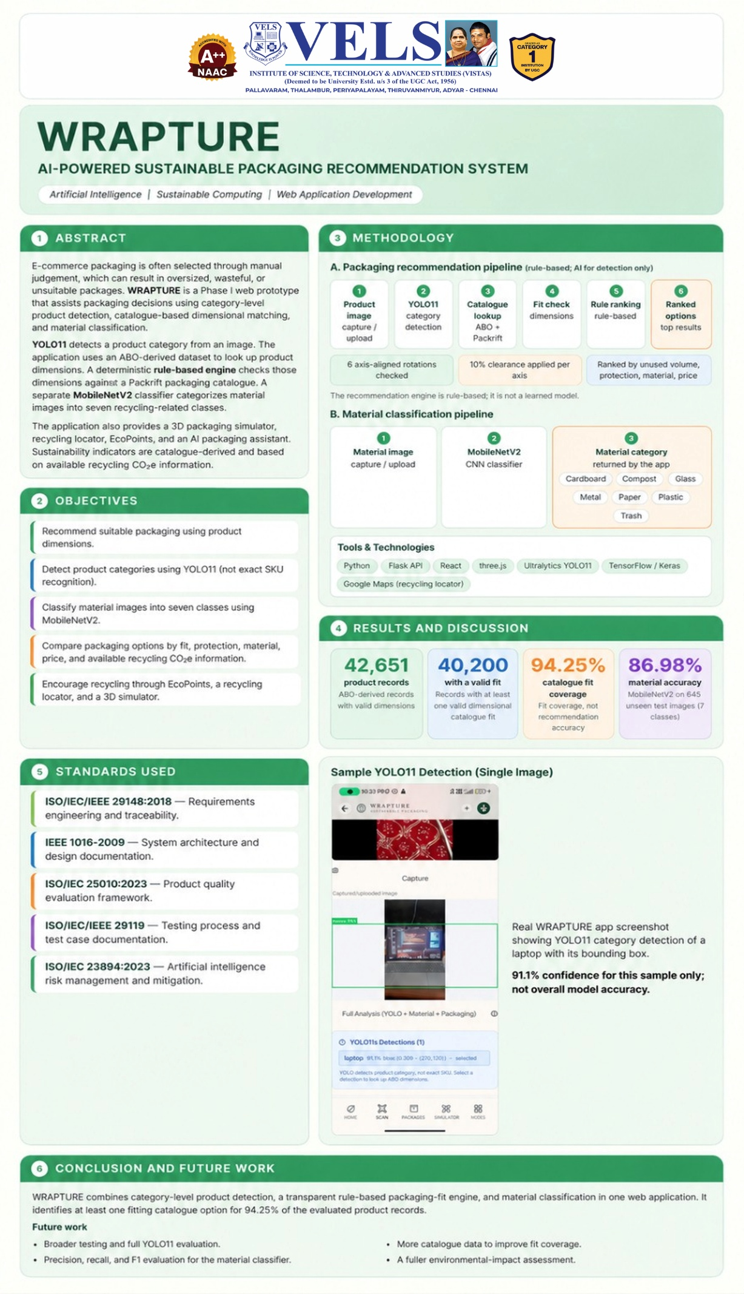

ABSTRACT
E-commerce depends on packaging that protects a product during handling and transport, but packaging is still commonly chosen by a person who looks at the product and picks a box or mailer based on approximate size and past experience. This does not scale well once the number of products and available packaging options grows, and it can lead to oversized packages, wasted material, and inconsistent choices between similar products. Wrapture is an AI-assisted sustainable packaging recommendation system built to support this decision rather than automate it away entirely. The system detects a product from an image using YOLO11, connects the detected category to structured product information available in the Amazon Berkeley Objects (ABO) dataset, and can separately classify a packaging material image into one of seven categories — cardboard, compost, glass, metal, paper, plastic, and trash — using a MobileNetV2-based classifier trained on 2,616 images and evaluated on 645 unseen test images, reaching a test accuracy of 86.98%. The central packaging decision is handled by a deterministic recommendation engine, not a learned model: it checks candidate packaging records from a real catalogue of 2,209 items sourced from Packrift (covering boxes, mailers, and poly bags), tries alternative orientations of the product, applies a 10% clearance margin, and compares the eligible options on unused volume, protection information, material, and unit price. When this approach was applied across the tested ABO products, 94.25% of them had at least one packaging option that physically fit under the defined clearance condition — a measure of packaging fit coverage, not of prediction accuracy. Wrapture additionally provides a 3D packaging simulator to visualise the chosen configuration, recycling-related sustainability information based on CO2e figures and EPA WARM considerations for qualifying corrugated packaging, a mobile-oriented application backed by a Flask API, and a compact administrative view. This report documents what has actually been implemented and tested in the current phase, and separates it clearly from features, such as automated weight measurement, that remain for future work.
Keywords:
Sustainable Packaging, Artificial Intelligence, YOLO11, Computer Vision, Material Classification, MobileNetV2, Packaging Recommendation, ABO Dataset, E-Commerce, 3D Packaging Simulation.

LIST OF FIGURES
Figure No. | Title | Page No.
Figure 3.1 | System Architecture of Wrapture | 14
Figure 4.1 | YOLO11-Based Product Detection (Laptop, 91.1% Confidence) | 19
Figure 4.2 | Real Packaging Catalogue – EcoShop (2,209 Records) | 24
Figure 4.3 | 3D Packaging Simulator – Material Preview and Configuration | 25
Figure 4.4 | Application Interface – All Tools Menu | 26
Figure 4.5 | Application Interface – Home Screen with Tool List | 27
Figure 4.6 | Main Home Screen – "What Are You Packaging?" | 28
Figure 4.7 | AI-Powered Packaging Innovation Overview Screen | 29
Figure 9.1 | Wrapture Home Page | 46
Figure 9.2 | About Wrapture and Mission | 47
Figure 9.3 | AI-Powered Packaging Recommender | 47
Figure 9.4 | AI-Powered Vision Scanner | 48
Figure 9.5 | Reverse Logistics and Recycling Locator | 48
Figure 9.6 | TrashGPT Sustainability Chatbot | 49
Figure 9.7 | EcoPoints Dashboard | 49
Figure 9.8 | 3D Packaging Simulator | 50
Figure 9.9 | Eco Shop | 50
Figure 9.10 | Admin Dashboard | 51

LIST OF TABLES
Table No. | Title | Page No.
Table 1.1 | Project Objectives | 7
Table 3.1 | Major System Modules | 16
Table 3.2 | Hardware Requirements | 17
Table 3.3 | Software Requirements | 17
Table 4.1 | Material Classification Classes | 21
Table 4.2 | Packaging Catalogue Categories | 23
Table 5.1 | Material Classification Result | 31
Table 5.2 | Packaging Catalogue Summary | 32
Table 5.3 | Functional Testing Summary | 34
Table 9.1 | Sample Packaging Catalogue Record | 45

LIST OF ABBREVIATIONS
Abbreviation | Full Form
AI | Artificial Intelligence
ML | Machine Learning
CNN | Convolutional Neural Network
YOLO | You Only Look Once
ABO | Amazon Berkeley Objects (dataset)
SKU | Stock Keeping Unit
UI | User Interface
UX | User Experience
API | Application Programming Interface
IoT | Internet of Things
CO2e | Carbon Dioxide Equivalent
EPA | Environmental Protection Agency
WARM | Waste Reduction Model

CHAPTER 1

INTRODUCTION

General
Packaging is a necessary part of almost every e-commerce order because a product has to survive handling, storage, and transport before it reaches a customer. The packaging chosen for an order affects several things at the same time: how well the product is protected, how much material is used, how much space it takes up during storage and delivery, and how much the packaging itself costs. When this decision is made manually, an operator typically looks at a product, estimates its size, and picks a box or mailer that seems close enough based on experience. This is manageable for a small number of product types, but it does not scale well as the catalogue of products and the number of available packaging options both grow. There is also an important difference between choosing a package that is simply larger than the product and choosing one that fits it well. An oversized package wastes material, increases the volume that has to be shipped, and can let the product move around inside the box during transit, which is itself a protection risk. A package that is too small does not protect the product adequately. Between these extremes there is usually a range of packaging options that could reasonably work, and picking a good one from that range means comparing dimensions, available clearance, protection information, material, and price together rather than looking at any single factor in isolation. A further complication comes up when the input available for a product is only an image rather than a catalogue entry with known dimensions. A person can generally recognise what a product is from a photograph, but the exact dimensions and weight required to check packaging fit are not always available at that point. Computer vision can help with recognising what the product is, and a structured product dataset can then be used to retrieve the dimensions needed for the next step. Wrapture was built around this idea: use AI for the parts of the process that involve recognising products and materials from images, and use a deterministic, checkable engine for the actual packaging decision, since packaging fit is a measurable problem that does not need to be treated as a black box.

Problem Description
Manual packaging selection does not scale efficiently once the number of products and packaging options increases. An operator choosing packaging by inspection cannot practically compare every available packaging record for a given product, so the packaging chosen is often based on habit or rough size matching rather than a systematic evaluation of the reasonable alternatives. This can lead to oversized packages, higher-than-necessary material use, inconsistent packaging choices for similar products handled by different people at different times. A related difficulty appears when the product is only available as an image, for example when a smaller seller is packing an item without a full catalogue entry on hand. There is no straightforward way to connect what a product looks like to the structured information — dimensions and weight — that is required to evaluate packaging options in the first place. There is also no simple way for a seller to know, from a packaging catalogue alone, which of several plausible options is the better choice in terms of fit, protection, material, and cost, without manually checking each one against the product. Wrapture addresses this by combining product detection, product information lookup, material classification, and a deterministic packaging recommendation engine into a single workflow, and by using a real packaging catalogue rather than a synthetic or example one, so that the recommendations reflect packaging that could actually be ordered.

Existing System
In most existing e-commerce and warehouse packing workflows, packaging selection still depends on manual judgement. An operator either follows a rough size-based rule, for example treating all items under a certain weight as suitable for a specific mailer, or repeats the packaging choice used previously for a similar product. Some warehouse management systems support basic dimensional rules or cartonization logic, and commercial cartonization tools exist that compare a fixed internal set of carton sizes against order dimensions to reduce shipping volume, but these are generally limited to a company's own predefined box sizes rather than a full external catalogue with varying material, protection ratings, and price. Separately, there is a body of work on computer vision for product recognition, on deep learning for material and waste classification, and on optimisation-based approaches to packaging and carton-set selection — including mixed-integer and evolutionary optimisation methods used in industrial cartonization research. However, in typical small and mid-sized e-commerce operations, these techniques are rarely combined into a single accessible tool. Product recognition, material identification, and packaging selection are usually treated as separate problems, and sustainability information such as recycling potential is rarely presented alongside the packaging decision itself rather than as a separate report generated afterwards.

Proposed System
Wrapture proposes an integrated workflow rather than a single isolated model. A product image is passed through a YOLO11-based detector to identify what the product is at a category level, for example "laptop" or "bottle", rather than an exact product SKU. The detected category can then be used to look up structured product information from the Amazon Berkeley Objects (ABO) dataset, where dimensions and weight are available for the corresponding records. Separately, a MobileNetV2-based classifier can identify the packaging material shown in an image across seven categories relevant to recycling and disposal. Once product dimensions are available, a deterministic packaging recommendation engine evaluates the real packaging catalogue — 2,209 records sourced from Packrift, covering boxes, mailers, and poly bags — and checks which options physically fit the product, considering more than one orientation and a 10% clearance margin for safe packing. The eligible options are then compared on unused volume, protection information, material, and unit price, so the system can present a reasoned recommendation instead of simply the first option that technically fits. The system also includes a 3D packaging simulator so a user can see the product inside the recommended packaging configuration, and it surfaces recycling-related CO2e information for supported packaging types. These pieces are delivered through a mobile-oriented application connected to a Flask backend, together with a compact admin dashboard for monitoring how the tools are being used.

Objectives
The objectives of this phase of the Wrapture project are summarised in Table 1.1.
No. | Objective
1 | Detect a product from an image using YOLO11 and connect the detected category to structured product data in the ABO dataset.
2 | Classify a packaging or waste material image into one of seven recycling-relevant categories using a MobileNetV2-based classifier.
3 | Build a deterministic packaging recommendation engine that checks physical fit, orientation, a 10% clearance margin, protection information, unused volume, material, and price against a real packaging catalogue.
4 | Provide a 3D visualisation of a recommended packaging configuration for the selected product.
5 | Present recycling-related sustainability information (CO2e, WARM-based considerations) alongside packaging recommendations without claiming a complete life-cycle assessment.
6 | Deliver the above as a usable mobile application with a Flask backend and a basic administrative view.
Table 1.1: Project Objectives

Scope of the Project
The current phase of Wrapture focuses on establishing the core AI, data, and recommendation components together with a working application. The scope includes product detection at the category level rather than exact SKU-level identification; product information retrieval from the available subset of the ABO dataset, where dimension and weight data exist for a given record; material classification into seven broad categories; and a deterministic packaging recommendation engine driven by the Packrift-based catalogue of 2,209 records. It also includes a 3D simulator for visualising a chosen configuration, sustainability information limited to recycling CO2e figures and general WARM-based considerations for qualifying corrugated packaging, and a mobile application interface with a supporting admin dashboard. The scope does not currently include automated physical weight or dimension measurement using hardware such as load cells or depth cameras, a production-scale backend handling live order data, or a complete life-cycle assessment of packaging environmental impact. This report describes Phase 1 of Wrapture: the AI models, the data, the recommendation engine, and the application. Items outside this phase are discussed in Chapter 6 as future work and are not presented as completed features.

Contributions
The main contribution of this project is bringing together, in one working application, several pieces that are usually treated separately: image-based product detection, structured product data lookup, material classification, and a transparent, rule-based packaging recommendation approach backed by a real catalogue rather than illustrative example data. Keeping the packaging decision deterministic and explainable, instead of delegating it to a learned model, means every recommendation can be traced back to the specific product dimensions, the clearance calculation applied, and the catalogue record that produced it. The project also contributes a working demonstration of how recycling-related sustainability information can be surfaced as part of the packaging decision itself, rather than as a separate report generated after the fact, and a 3D visualisation feature that gives a more concrete sense of the recommended packaging than numbers alone would provide.

CHAPTER 2
LITERATURE REVIEW

Sustainable Packaging
Sustainable packaging is generally discussed in terms of reducing material use, improving recyclability, and lowering the environmental footprint of the packaging life cycle, while still protecting the product it contains. Industry analyses of e-commerce logistics consistently point out that oversized packaging increases both shipping cost and material waste, and that matching packaging more closely to the product it contains is one of the more direct ways to reduce both. Cartonization software used in warehouse operations, for instance, automates packaging size selection using product dimensions, weight, and shape so that orders are not routinely shipped in unnecessarily large boxes. A study reported by Supply Chain Dive describes carton set optimization tested in e-commerce warehouses across three industries, where it helped DHL save between 5% and 7% on annual shipping costs. These are results from that study, not from Wrapture, but they support the basic premise behind this project: better-fitting packaging, chosen systematically rather than by habit, has a measurable effect on cost and material use. Wrapture does not report a cost or carbon saving figure of its own.

Artificial Intelligence in Packaging Optimization
Applying optimisation techniques to packaging decisions is an active area outside pure academic research as well. Fraunhofer IML, for example, has described its CASTN (Carton Set Optimization) software, which takes order, item master, and packing data and calculates a carton set that gives better volume utilisation for a shipping company. DHL Supply Chain has also described an AI-based tool, OptiCarton, that optimises box filling from an existing set of cartons. These systems generally operate on a company's own carton set and its order history, and they mainly address which carton sizes to stock or how to fill an existing set. Wrapture's recommendation engine is closer to a per-product check: given a specific product and an existing packaging catalogue, it works out which available packaging options are suitable for that product. It is a simpler system than the industrial tools above and works at a much smaller scale.

Computer Vision for Product Detection
Object detection models are commonly used to identify what an object is and where it is located in an image. The YOLO (You Only Look Once) family of detectors is widely used for this kind of task because it processes an image in a single pass and produces bounding boxes with class labels and confidence scores, which makes it practical for interactive applications where a result is needed quickly after a photo is taken. Wrapture uses YOLO11, the most recent version of this detector family maintained by Ultralytics, to identify a product category from a captured or uploaded image. YOLO11 identifies the category of object present in an image, along with a bounding box and a confidence score, but it does not identify the exact stock-keeping unit (SKU) of the product, nor does it measure the product's physical dimensions from the image. In the implemented prototype, a laptop was detected with a confidence of approximately 91.1%, which is used only to establish the product category; the corresponding physical dimensions are then obtained separately from the product dataset rather than estimated from the photograph.

Deep Learning for Material Classification
Convolutional neural networks (CNNs) are the standard approach for image classification tasks such as identifying the material type shown in a photograph, and lightweight CNN architectures are preferred when a model needs to run responsively as part of an interactive application. MobileNetV2, introduced by Sandler, Howard, Zhu, Zhmoginov, and Chen in 2018, is one such architecture: it uses an inverted residual structure with lightweight depthwise convolutions to reduce the number of parameters and computations needed compared with larger CNNs, while still achieving competitive accuracy on standard image classification benchmarks. Wrapture uses a MobileNetV2-based classifier to sort a material image into one of seven categories relevant to recycling and disposal: cardboard, compost, glass, metal, paper, plastic, and trash. The model was trained using 2,616 labelled images and evaluated on 645 unseen test images that were not part of training, reaching a test accuracy of 86.98%. This places the classifier's performance in a practically useful range for a supporting feature, while leaving room for improvement with a larger or more varied training set, which is discussed later as a limitation.

Packaging Recommendation and Optimization
Selecting a packaging option that fits a product, once its dimensions are known, is fundamentally a geometric fitting and comparison problem rather than a prediction problem. Given a product's length, width, and height, a candidate package fits if the product (possibly after being reoriented) is smaller than the internal package dimensions by some safety margin. Cartonization literature typically calls this margin a clearance allowance, and it exists because a package that exactly matches product dimensions leaves no room for cushioning material or for minor manufacturing tolerance in either the product or the package. Wrapture's recommendation engine follows this established approach directly: it checks a product's dimensions against each candidate record in the packaging catalogue, tries the product in more than one orientation, and requires a 10% clearance margin before considering an option a physical fit. Because this check is deterministic — the same product dimensions and the same catalogue will always produce the same set of eligible packages — the recommendation engine is treated in this project as a rule-based system rather than a machine-learned one, which keeps the reasoning behind each recommendation traceable back to specific numbers rather than to a model's internal weights.

3D Packaging Visualization
Interactive 3D visualisation in the browser or a mobile application is commonly implemented using libraries such as three.js, which provide a JavaScript API over WebGL for rendering and manipulating 3D scenes without requiring a native graphics engine. Such libraries are widely used for product configurators and preview tools where a user benefits from seeing an object rendered in three dimensions rather than reading a list of numbers. Wrapture's 3D Packaging Simulator, built with three.js, follows this same pattern: it renders a simplified representation of the product inside a chosen packaging material so a user can get a visual sense of the configuration alongside the catalogue data driving the recommendation. This is a visualisation and decision-support aid, not an engineering-grade or physically accurate structural simulation of how the packaging would behave under real loading conditions, and it should not be read as a substitute for physical packaging validation.

Existing Systems and Limitations
Existing packaging tools generally fall into two groups. The first is warehouse-level cartonization software, which optimises a company's own box inventory against historical order data but does not typically include product recognition from images or present sustainability information as part of the same interface. The second is broader e-commerce sustainability tooling, which reports on material use or emissions at a summary level — for example, over a monthly period or across a whole account — rather than at the level of an individual packaging decision for a specific product. A common limitation across both groups is that they treat product identification, material handling, and packaging selection as separate systems maintained by different tools or teams. This makes it harder for a smaller seller, who does not have all this information readily available, to make an informed packaging choice quickly. It also means that sustainability information, when it exists, is often disconnected from the decision it should be informing.

Research Gap
Based on the review above, the gap this project addresses is not the invention of a new detection or classification algorithm — YOLO11 and MobileNetV2 are both established, well-documented architectures — but the integration of image-based product identification, material classification, a real and reasonably large packaging catalogue, a transparent fit-and-cost recommendation engine, and recycling-related sustainability information into a single accessible workflow aimed at the scale of an individual product decision rather than a warehouse-wide box-inventory decision. Wrapture's current implementation is a first step in this direction, built and tested at a scale consistent with a final-year project rather than a production system, with the specific limitations of that scope discussed in Chapter 6.

CHAPTER 3
SYSTEM DESIGN

Existing System
As discussed in Chapter 2, packaging selection in most existing workflows is either fully manual or supported by cartonization software limited to an organisation's own fixed set of carton sizes. Product identification from an image, if it happens at all, is typically handled by a separate barcode or SKU lookup rather than a general-purpose visual detector, and sustainability information, when available, is usually reported separately from the packaging decision itself. There is no single, accessible workflow that takes a product image as input and produces a packaging recommendation backed by a real, sizeable catalogue together with sustainability context, which is the gap Wrapture is built to fill. In such existing systems, the different pieces of information a packer actually needs — what the product is, how big it is, what packaging is available, and what that packaging costs and is made of — usually live in different tools altogether: a barcode scanner or SKU lookup for identification, a spreadsheet or ERP module for dimensions, and a supplier's own website or price list for packaging options. Bringing these together for a single decision means switching between systems and manually cross-referencing values, which is exactly the kind of repetitive, error-prone task that a connected system can remove.

Proposed System
Wrapture is structured as a pipeline of modules connected through a Flask backend and consumed by a mobile-oriented React frontend. A product image is first passed to the YOLO11 detector, which returns a detected category and a bounding box. The detected category is used to query the ABO-derived product dataset for structured information such as dimensions and weight, where available. In parallel, a user can submit a separate material image to the MobileNetV2 classifier to identify the packaging or waste material shown. Once dimensions are available for a product, the packaging recommendation engine evaluates the Packrift-derived catalogue and returns a ranked set of physically fitting options, which can then be explored further in the 3D packaging simulator and reviewed alongside recycling-related sustainability information. The backend exposes the AI and data components through a Flask API that the mobile application calls: detection, product lookup, material classification, recommendation, and catalogue browsing. This keeps the responsibilities of each part separate. The detector only deals with images and categories, the recommendation engine only deals with dimensions and catalogue records, and the frontend collects input and displays whatever the backend returns.

System Architecture
Figure 3.1 shows the overall architecture of the system at module level. Input flows from the product image through detection and product information lookup, while a separate material classification path can be used independently. Both paths feed into the packaging recommendation engine, which also draws on the packaging catalogue. The output of the engine feeds the packaging recommendation and detail screens, the 3D simulator, and the sustainability information screens, all of which are served through the same mobile application and Flask backend.
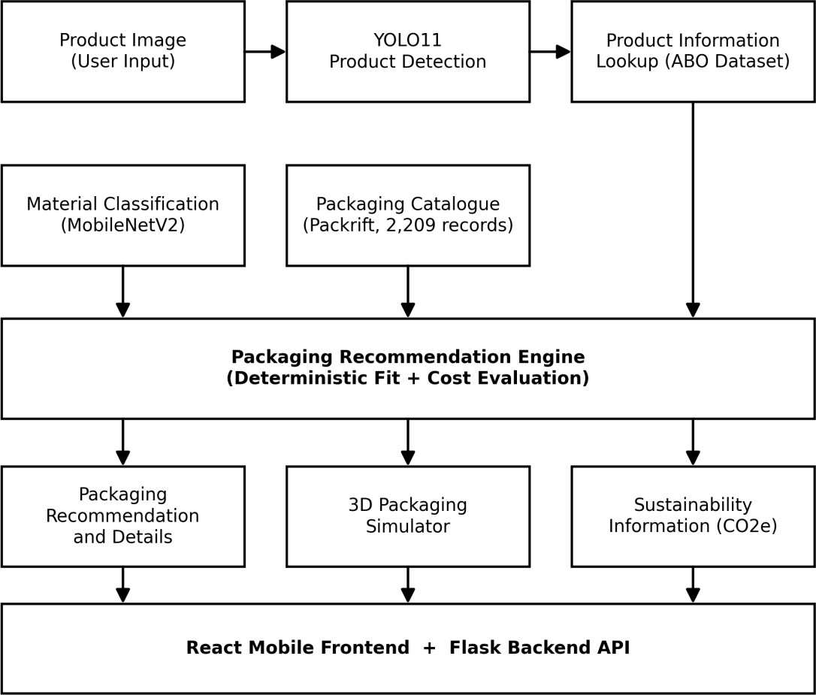
Figure 3.1: System Architecture of Wrapture
The architecture can be read as three loose layers. At the bottom is the data layer, made up of the ABO-derived product dataset and the Packrift-derived packaging catalogue. In the middle is the processing layer, made up of the YOLO11 detector, the MobileNetV2 classifier, and the packaging recommendation engine, all exposed through the Flask API. At the top is the presentation layer, the React-based mobile frontend, which captures input, calls the backend, and renders the response.

Overall Workflow
The typical end-to-end workflow in the current implementation proceeds as follows: the user opens the AI Product Scanner and captures or uploads a product image; YOLO11 detects the product category and confidence score; the user selects a detection to look up the corresponding ABO product record; the packaging recommendation engine evaluates the catalogue against the retrieved dimensions, alternative orientations, and the 10% clearance rule; the user reviews the recommended packaging option and its alternatives, including price, protection information, and recycling CO2e where available; the user can then open the 3D Packaging Simulator to visualise the chosen configuration, and finally review sustainability information associated with the packaging choice. Separately, a user can use the Material Analysis tool to classify a photographed material into one of the seven supported categories without going through the full product workflow. Two secondary paths exist alongside this main workflow. The first is direct catalogue browsing through EcoShop, which lets a user search and filter the 2,209 packaging records without starting from a product photograph at all — useful when a packer already knows roughly what they are looking for and wants to check price or availability directly. The second is the set of supporting tools (TrashGPT, EcoPoints, Reverse Logistics, Review Analyzer) reachable from the home screen, which sit alongside the core workflow rather than being steps within it. Both paths reuse the same backend and the same underlying data as the main workflow, so a packaging record viewed in EcoShop, for instance, is the same record the recommendation engine would have considered for a matching product.

System Modules
Table 3.1 summarizes the major modules that make up the current implementation and the role each one plays.
Module | Role
AI Product Scanner | Runs YOLO11 on a captured or uploaded image to detect the product category and confidence score.
Product Information Lookup | Retrieves dimensions, weight, and category information for the detected product from the ABO-derived dataset.
Material Classification | Classifies a material image into one of seven categories using the MobileNetV2-based model.
Packaging Recommendation Engine | Evaluates the packaging catalogue against product dimensions, orientation, and clearance rules to produce a ranked set of fitting options.
Packaging Catalogue Integration | Provides real packaging records (SKU, dimensions, material, price, protection, recycling CO2e) sourced from Packrift.
3D Packaging Simulator | Renders a visual, three.js-based representation of the product inside the selected packaging material.
Sustainability Insights | Presents recycling CO2e and WARM-related information associated with a packaging choice.
Application Interface | Mobile-oriented React frontend covering the scan, recommendation, simulator, and sustainability screens.
Admin Dashboard | Compact operational view summarizing tool usage across the application.
Table 3.1: Major System Modules
Each module in Table 3.1 is intentionally narrow in what it does. The AI Product Scanner, for example, does not attempt to also decide on packaging; it simply reports what it detected and how confident it is. This keeps individual modules easier to reason about and test in isolation, and it mirrors, at a smaller scale, the same layered separation described for the overall architecture in Section 3.3.

Data Flow
Data flows through the system in a mostly linear sequence for the main product workflow. An image captured on the device is sent to the Flask backend, where the YOLO11 model performs detection and returns the result as JSON. The selected detection is used to query the product dataset, and the resulting dimensions are passed, along with the packaging catalogue, into the recommendation engine, which returns a ranked list of eligible packaging records. This list is rendered on the packaging recommendation and detail screens, and the same underlying data (product type, dimensions, weight, and selected packaging material) is reused when the user opens the 3D simulator, so that the simulator reflects the same values rather than a separate, disconnected input. The product image, detection result, and chosen packaging option belong to one interaction with one product. The home screen additionally shows running counts of recommendations generated and material scans completed. The packaging catalogue and product dataset are used as reference data: the recommendation engine reads from them and does not modify them.

Hardware Requirements
Table 3.2 lists the hardware used during development and testing of the current implementation. These are ordinary development and mobile-testing devices rather than any specialised hardware; no dedicated sensor hardware (such as a load cell or depth camera) is part of the current implementation.
Component | Specification / Purpose
Development laptop | Used for model training, backend development, and application development.
Android smartphone | Used to run and test the mobile application, capture product images, and connect to the Flask backend over Wi-Fi.
Internet connection | Required for the mobile device and development machine to communicate over the local network / Flask API.
Table 3.2: Hardware Requirements
This minimal hardware footprint is a direct consequence of keeping the AI models on the backend rather than running inference on the mobile device itself. The Android device only needs to be able to capture a photograph and send it over the network; the actual detection and classification computation happens on the development machine running the Flask server. This keeps the mobile application lightweight and means it can, in principle, run on a wide range of Android devices rather than only ones capable of running deep learning models locally.

Software Requirements
Table 3.3 lists the main software components used to build and run the current implementation.
Component | Purpose
Python | Backend implementation, model training and inference (YOLO11, MobileNetV2).
Flask | Backend REST API connecting the mobile application to the AI models, product dataset, and packaging catalogue.
React | Mobile-oriented frontend application (screens, navigation, state).
three.js | 3D rendering used by the 3D Packaging Simulator.
Ultralytics YOLO11 | Product detection model and training/inference framework.
TensorFlow / Keras | Training and inference for the MobileNetV2-based material classifier.
ABO dataset (subset) | Source of structured product information (dimensions, weight, category).
Packrift catalogue export | Source of the real packaging records used by the recommendation engine.
Table 3.3: Software Requirements
Flask was chosen for the backend because it is lightweight enough to expose a small set of model-serving endpoints without the overhead of a larger web framework, which suited a project-scale backend that did not need built-in authentication, admin panels, or an ORM at this stage. React was chosen for the frontend because it allows the same component-based structure to be reused across the many screens described in Section 4.8. three.js was chosen for the 3D simulator specifically because it can run inside the same JavaScript-based frontend without requiring a separate native rendering engine.

CHAPTER 4
IMPLEMENTATION AND METHODOLOGY

AI Product Detection using YOLO11
Product detection is implemented using YOLO11, run through the Flask backend so that the mobile application only needs to send an image and receive a JSON response containing detected classes, bounding boxes, and confidence scores. In the implemented prototype, a photograph of a laptop was correctly detected with a confidence of 91.1%, with a bounding box roughly spanning the visible extent of the device in the captured frame. Figure 4.1 shows this detection as displayed in the application, including the interface note that YOLO detects the product category rather than the exact SKU, and that the user selects a detection to proceed to dimension lookup.
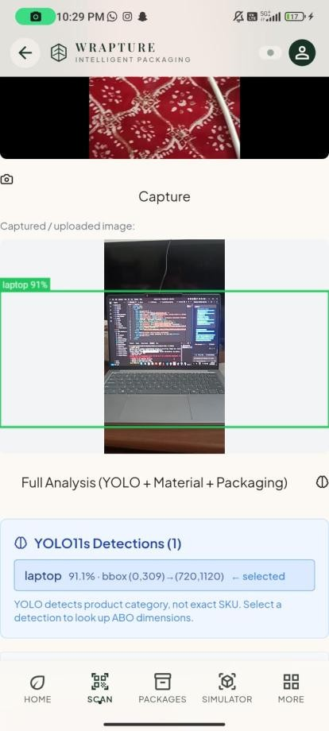
Figure 4.1: YOLO11-Based Product Detection (Laptop, 91.1% Confidence)
The detector is used only to establish what kind of object is present in the frame. It does not attempt to read a barcode or otherwise identify an exact product listing, and it does not estimate physical dimensions from the image; both of these steps are handled separately, as described in the next section. This separation keeps the detector's job simple and keeps the more sensitive part of the process — the dimensions that will decide whether a package physically fits — anchored to structured data rather than an image-based estimate that could be far less reliable.
On the backend, the captured image is passed to the YOLO11 model, which returns one or more detections, each with a class label, a confidence score, and a bounding box given as pixel coordinates. Where more than one detection is returned for an image, the interface lists each one (the application shows this as "YOLO11s Detections (n)") and lets the user pick the one that corresponds to the item they actually intend to package, rather than assuming the highest-confidence detection is automatically correct. This matters in practice because a captured frame can sometimes include more than one recognisable object — for example, a laptop sitting on a patterned surface, as in the tested example — and the user is in the best position to confirm which detected object is the one being packaged. A confidence score is reported alongside every detection so the user can judge how far to trust it. In the tested example, a confidence of 91.1% for the "laptop" class was considered reliable enough to proceed.

Product Information Retrieval
Once a product category has been detected, the application looks up structured product information from a dataset derived from the Amazon Berkeley Objects (ABO) dataset. The full ABO dataset published by Amazon and UC Berkeley contains 147,702 product listings across a wide range of household object categories, with metadata attributes including category, dimensions, weight, and material where available. For this project, a working subset of approximately 42,650 products across approximately 524 product types was used — records for which usable dimension information exists, since dimension data is what the packaging recommendation step actually needs. Not every record in the dataset includes complete weight information, and this is treated as a known limitation rather than something the system works around silently: where a value is not available for a given product, the interface does not present a fabricated number in its place. This lookup step is what converts a detected category such as "laptop" into the concrete length, width, and height figures required by the recommendation engine in the next stage. The ABO subset organises products into roughly 524 product types, and the application text in Figure 4.1 states that the user selects a detection to look up ABO dimensions. The dimension values that reach the recommendation engine therefore come from the product dataset and not from the photograph. Where dimensions or weight are missing for a record, this remains a limitation of the source data.

Material Classification
The material classification component uses a convolutional neural network based on the MobileNetV2 architecture to classify an image into one of seven categories: cardboard, compost, glass, metal, paper, plastic, and trash. These categories were chosen because they correspond to common recycling and disposal streams rather than to packaging material types alone, which makes the classifier useful both for packaging decisions and for general waste-sorting guidance within the application.
No. | Class | Typical Examples
1 | Cardboard | Corrugated boxes, cartons
2 | Compost | Food waste, organic material
3 | Glass | Bottles, jars
4 | Metal | Cans, foil
5 | Paper | Paper sheets, wrappers
6 | Plastic | Bottles, poly bags, containers
7 | Trash | Non-recyclable mixed waste
Table 4.1: Material Classification Classes
The model was trained on 2,616 labelled images and evaluated on a separate set of 645 unseen test images, achieving a test accuracy of 86.98%. This is a single overall test accuracy figure; precision, recall, F1-score, and confusion-matrix values were not computed as part of this phase of the project and are noted as a possible extension in Chapter 6 rather than reported here as invented numbers. In the application, this model is exposed through the Material Analysis tool, where a captured photograph is classified instantly and the predicted category is returned to the user. MobileNetV2 was chosen for this task specifically because it is designed to run efficiently rather than to maximise accuracy at any computational cost. Since the model needs to respond quickly enough for an interactive "classify instantly" experience, as labelled on the Material Analysis screen, a lighter architecture that trades a small amount of accuracy for substantially fewer parameters and faster inference was considered a reasonable choice for this project's scale, compared with larger CNN architectures that might reach a somewhat higher accuracy but respond more slowly and require more computational resources to serve. The seven material classes were kept deliberately broad rather than being split into finer sub-categories (for example, separating clear glass from coloured glass, or different plastic resin types). This was a conscious trade-off: finer-grained classes would require substantially more labelled training data per class to reach a comparable accuracy, and the coarser categories used here are already directly meaningful for the recycling and disposal decisions the classifier is meant to support.

Packaging Recommendation Engine
The packaging recommendation engine is the deterministic core of Wrapture. Given a product's dimensions (and weight, where available), the engine iterates over the packaging catalogue and checks, for each candidate record, whether the product fits inside the package's internal dimensions in at least one of several tried orientations, after applying a 10% clearance margin on each relevant dimension. Records that pass this fit check are considered physically eligible and are then compared using additional information available in the catalogue: whether the record has documented protection information (such as corrugated board grade), how much unused volume remains once clearance is applied, the packaging material, and the unit price. This design was chosen deliberately over a black-box predictive model because packaging fit is a matter of geometry and stated catalogue properties, not something that benefits from being learned approximately from examples. Every recommendation produced by the engine can be explained in terms of the specific dimensions checked, the orientation that was found to fit, the clearance margin applied, and the catalogue record that was selected, which makes the system's behaviour auditable rather than opaque. Concretely, for a product with dimensions L × W × H, the engine applies the 10% clearance rule by requiring the internal package dimensions to be at least L×1.10, W×1.10, and H×1.10 along some matching assignment of axes. Because a product does not have to be placed inside a package in only one way, the engine checks the product's dimensions against a package's internal dimensions across the reasonable orientation permutations (for example, treating the product's longest side as fitting along the package's length, width, or height in turn), rather than assuming a single fixed orientation. A package is recorded as eligible for a product as soon as at least one orientation satisfies the clearance condition on all three axes; if none do, that package is excluded from the candidate list for that product regardless of how close it comes on one or two dimensions alone. Once the eligible set is built, the engine does not simply return the first match. It computes the unused volume for each eligible package (the package's internal volume minus the product's volume) so that options which fit the product closely, rather than loosely, can be preferred, and it retains the catalogue's own protection information, material, and unit price for each option so these can be compared side by side. The final ranking presented to the user favours options with lower unused volume and adequate protection information at a reasonable price, but all eligible alternatives remain visible rather than being hidden once a top recommendation is chosen, so a user can override the default choice if a specific price or material constraint matters more to them for a given order.

Packaging Catalogue Integration
The packaging catalogue used by the recommendation engine is sourced from Packrift and contains 2,209 usable packaging records after filtering to records with complete enough data to be evaluated by the engine. The catalogue spans three broad package types, summarised in Table 4.2.
Category | Description
Boxes | Box records, including corrugated cardboard bin boxes as seen in the EcoShop listings.
Mailers | Mailer records in the catalogue.
Poly bags | Poly bag records in the catalogue.
Table 4.2: Packaging Catalogue Categories
Each catalogue record includes a SKU, package type, material, dimensions, unit price, pack quantity, protection information where available, a recycling CO2e figure where available, and a reference back to the corresponding Packrift listing. Figure 4.2 shows the EcoShop screen, which lets a user browse the catalogue directly, search by title, SKU, or material, and view the same fields — dimensions, protection, and recycling CO2e — that the recommendation engine uses internally, confirming that these are real catalogue values rather than numbers generated only for display. Using a real catalogue rather than a small hand-built list of example packages was an important design decision. A catalogue of this size will not have every field for every record (protection information and recycling CO2e are listed only where available), so the engine treats these as optional information and the dimensions, material, and price as the main inputs.
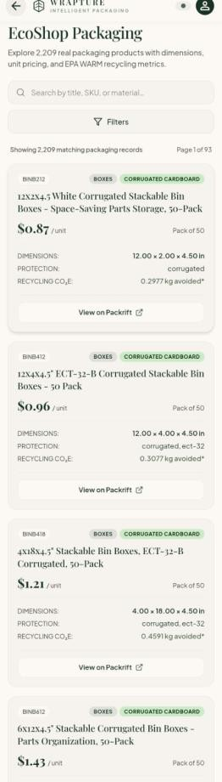
Figure 4.2: Real Packaging Catalogue – EcoShop (2,209 Records)

3D Packaging Simulator
The 3D Packaging Simulator, shown in Figure 4.3, lets a user select a product type, enter or confirm its dimensions and weight, and choose a packaging material — Corrugated Cardboard, Kraft Paper, Plastic/Poly, or an "Any / Best Fit" option — and then view a rendered preview of the product inside that packaging. The simulator is built using three.js and is explicitly labelled in the interface as a visualisation rather than an engineering simulation; the same screen notes that its underlying metrics come from actual catalogue records rather than invented values.
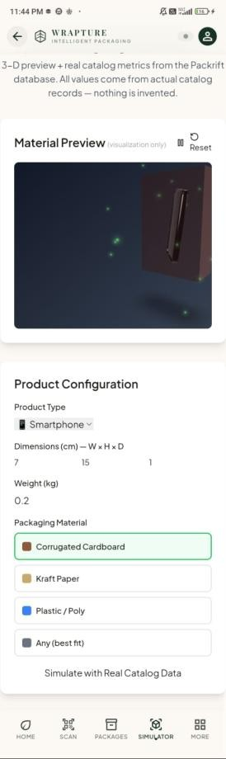
Figure 4.3: 3D Packaging Simulator – Material Preview and Configuration
This feature is intended to help a user get a more concrete sense of a recommended packaging configuration than a table of numbers alone provides. It is not a substitute for physical testing of how packaging would perform under real-world handling, drop, or compression conditions, and the report does not treat it as an industrial-grade or physically accurate structural simulation. The simulator screen states that its preview and metrics come from real catalogue records from the Packrift database, so it is tied to the same data used by the recommendation engine and not to invented values.

Sustainability Analysis
Sustainability information in Wrapture is limited to what the underlying catalogue data actually supports: recycling-related CO2e figures for catalogue records where this data is available, along with general considerations drawn from the EPA's Waste Reduction Model (WARM) for qualifying corrugated packaging. This information is presented as decision-support context alongside a packaging recommendation, not as a certified environmental claim and not as a complete life-cycle assessment covering manufacturing, transport, and end-of-life impact for a given package. Where a catalogue record does not include a recycling CO2e figure, the interface does not substitute an estimated or invented value.

Application Interface
The application interface is built as a mobile-oriented React frontend that communicates with the Flask backend over a configurable API URL, shown in Figure 4.4. This configuration screen allows the backend address to be set explicitly (for example, a LAN IP address when the mobile application is tested on a physical Android device rather than an emulator on the same machine as the backend), which reflects the current development and testing setup rather than a fixed production deployment.
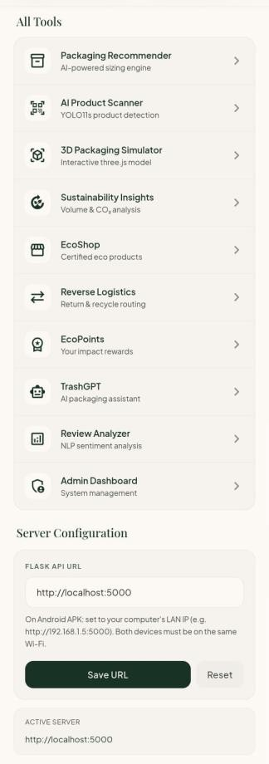
Figure 4.4: Application Interface – All Tools Menu
The main navigable tools are organised in an "All Tools" list, shown together with a home tab, a scan tab, a packages tab, a simulator tab, and a more tab in the bottom navigation, as shown in Figure 4.5. From the home screen, the application shows a live status indicator confirming the connection to the Flask backend, and the home screen also shows counts of recommendations generated and material scans completed.
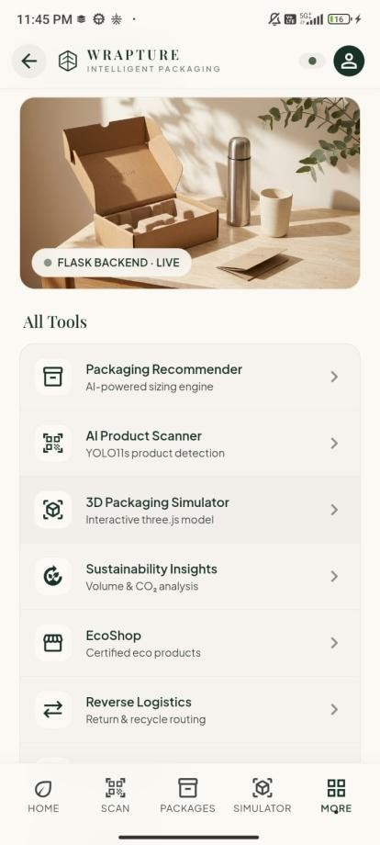
Figure 4.5: Application Interface – Home Screen with Tool List
The main product workflow begins on the "What are you packaging?" screen, shown in Figure 4.6, where a user starts by scanning a product. From here the application follows the sequence described in Section 3.4: product input, detection, product information lookup, packaging recommendation, packaging detail review, 3D visualisation, and sustainability information.
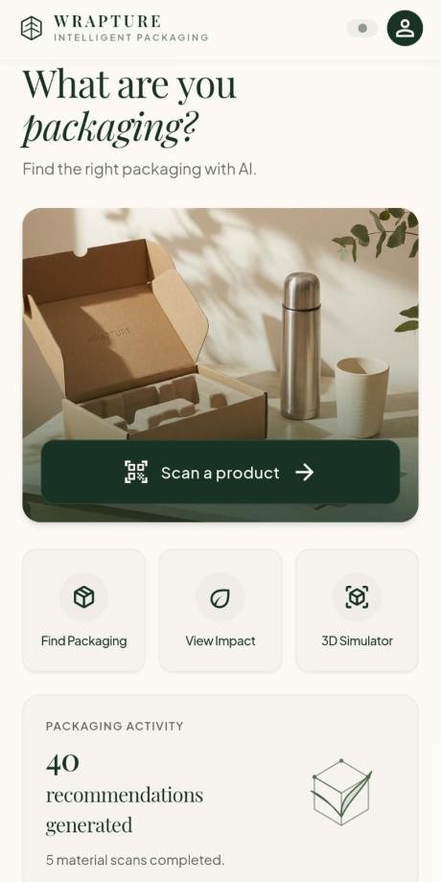
Figure 4.6: Main Home Screen – "What Are You Packaging?"
A separate screen, shown in Figure 4.7, introduces the broader concept behind the application — combining AI-based packaging optimisation, carbon-footprint-related information, a gamified EcoPoints rewards system, and a dual interface intended to support both larger sellers (using product-ID based lookup) and smaller, artisanal sellers (using image-based scanning). This screen is descriptive and positions the project conceptually; the specific measured results reported in Chapter 5 are what the current implementation actually delivers, and this distinction is kept clear throughout the report.
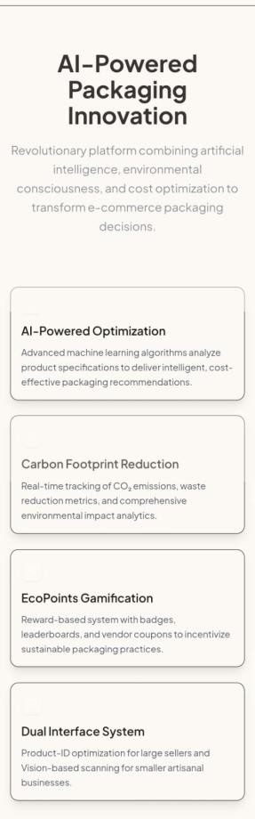
Figure 4.7: AI-Powered Packaging Innovation Overview Screen
Beyond the core packaging workflow, the interface also exposes a set of supporting tools accessible from the home screen's "More Tools" section: EcoShop for browsing the packaging catalogue directly, TrashGPT as an AI packaging assistant, EcoPoints for tracking usage-based rewards, Returns/Reverse Logistics for return and recycle routing, and a Review Analyzer that performs NLP-based sentiment analysis on packaging-related reviews. These are part of the same application shell and share the same Flask backend, though they are secondary to the core detection-to-recommendation workflow described earlier in this chapter.

Admin Dashboard
The application includes a compact Admin Dashboard intended as an operational view of the system rather than a full production analytics platform. It is organised around categories such as total scans, products identified, recommendations generated, packaging options viewed, packaging activity, recent activity, and overall system status. The dashboard reflects usage of the application's own tools and does not connect to any external production infrastructure, live order-management system, or database beyond what the application itself records; no backend uptime, live traffic, or deployment-region statistics are part of the current implementation, and none are reported in this document.

End-to-End Integration
All of the modules described above are integrated through the Flask backend, which exposes the YOLO11 detector, the product information lookup, the MobileNetV2 classifier, the packaging recommendation engine, and the packaging catalogue as a set of API endpoints consumed by the React-based mobile frontend. This keeps the AI and data-heavy components on the backend, where they can be updated independently of the mobile application, while the frontend focuses on presenting the results — detections, recommendations, 3D visualisations, and sustainability information — in a single connected workflow rather than as separate disconnected tools.

CHAPTER 5
RESULTS AND DISCUSSION

Experimental Results
This chapter reports the results obtained from testing the implemented components of Wrapture: the YOLO11-based product detector, the MobileNetV2-based material classifier, the packaging recommendation engine evaluated against the packaging catalogue, and basic functional testing of the application as a whole. Each result is reported at the level it was actually measured, and the different kinds of metrics — model performance, packaging fit coverage, catalogue size, and functional test outcomes — are kept clearly separate rather than mixed together, since they measure different things. Results are organised in the same order as the modules were introduced in Chapter 4, moving from the AI components through to the recommendation engine, the catalogue, the 3D simulator, sustainability information, and finally whole-application functional testing. This ordering is intended to make it straightforward to trace a given result back to the specific module and implementation section that produced it, and to avoid presenting any single number without the context of what was actually being measured and under what conditions.
The one model-level metric available for this phase is the test accuracy of the material classifier, given in Table 5.1.
Item | Value
Model | MobileNetV2-based classifier
Number of classes | 7
Training images | 2,616
Unseen test images | 645
Test accuracy | 86.98%
Table 5.1: Material Classification Result

AI Product Detection Results
The YOLO11 detector was tested informally on product images captured through the application during development. In the representative case documented in this report, a laptop was correctly detected with a confidence score of 91.1%, with a bounding box covering the visible extent of the device in the frame, as shown earlier in Figure 4.1. This confirms that the detector is functioning correctly for at least this product category under the lighting and framing conditions used during testing. A broader, formally logged evaluation across many product categories and confidence thresholds was not carried out as part of this phase, and is noted in Chapter 6 as a natural next step rather than reported here with numbers that were not actually measured. A single detection result demonstrates that the pipeline works end to end for one real product and one real photograph: image capture, the Flask backend, the YOLO11 model, and a returned label, bounding box, and confidence back in the interface. It does not establish a stable accuracy figure across the product categories covered by the ABO dataset, which would need a larger labelled test set. Because the current implementation asks the user to select the detection that matches the item being packaged, the workflow does not depend on the detector being perfect on every attempt.

Packaging Recommendation Results
The central quantitative result for the recommendation engine concerns packaging fit coverage: when the deterministic fit check (multiple orientations, 10% clearance) was applied across the tested ABO products against the 2,209-record packaging catalogue, 94.25% of the tested products had at least one packaging option that physically fit under the defined clearance condition. This figure describes the proportion of products for which a valid packaging match exists in the catalogue; it is not a prediction accuracy figure, since the recommendation engine does not predict a label to be checked against ground truth — it directly evaluates a geometric fit condition that is either true or false for a given product-package pair. For the remaining share of tested products, no catalogue record satisfied the fit and clearance condition, which most often reflects a genuine gap in the catalogue for that product's specific dimensions (for example, an unusually large or unusually shaped item) rather than a flaw in the fit-checking logic itself. Improving this figure further is mainly a matter of catalogue completeness. Expanding the catalogue is the more direct route to improving coverage than changing the fit-checking approach. This is reflected in Chapter 6.

Packaging Catalogue Results
Table 5.2 summarises the packaging catalogue actually integrated into the recommendation engine and browsable through the EcoShop screen shown earlier in Figure 4.2.
Metric | Value
Total usable packaging records | 2,209
Package categories covered | Boxes, Mailers, Poly bags
Data source | Packrift catalogue export
Fields available per record | SKU, type, material, dimensions, price, pack quantity, protection info (where available), recycling CO2e (where available), Packrift reference
Table 5.2: Packaging Catalogue Summary

3D Simulation Results
The 3D Packaging Simulator was tested by configuring representative products (for example, a smartphone with dimensions of 7 × 15 × 1 cm and a weight of 0.2 kg) and selecting each of the four available packaging materials. In each case, the simulator rendered a corresponding visual preview and, as shown in Figure 4.3, displayed catalogue-derived metrics alongside the 3D preview rather than a purely illustrative model. This confirms that the simulator is correctly connected to the same underlying product and catalogue data used elsewhere in the application, rather than operating as a disconnected demo screen.

Sustainability Analysis
Sustainability-related information was checked against the underlying catalogue records rather than tested as an independent model, since this feature is a direct presentation of stored CO2e figures and WARM-based considerations rather than a predictive component. Where a catalogue record includes a recycling CO2e value, this figure is shown to the user alongside the packaging recommendation, as visible in the EcoShop listings in Figure 4.2 (for example, values such as 0.2977 kg CO2e avoided per record). No aggregate environmental claim, such as an overall carbon savings percentage for the system as a whole, is calculated or presented, since the current implementation does not have the scope of data required to support such a claim responsibly. The EPA's WARM model, which some of these recycling CO2e figures draw on for qualifying corrugated packaging, is itself a life-cycle-informed estimation tool rather than a direct emissions measurement — it estimates greenhouse-gas impact for different waste management pathways (recycling, landfill, combustion, composting) based on material type and established emission factors, rather than measuring the actual emissions of a specific shipment. Wrapture surfaces WARM-based figures where the catalogue data provides them, but does not perform its own independent life-cycle calculation, and this dependency on the source catalogue's own data quality is treated as a limitation rather than something the project claims to have validated independently.

Functional Testing
Functional testing focused on confirming that each screen in the application behaves as intended and that data flows correctly between the backend and the mobile frontend. Table 5.3 summarises the main functional checks performed.
Test Area | Check Performed | Result
Backend connectivity | Flask API reachable from mobile device over LAN IP | Passed
Product detection | YOLO11 detection returns category, bounding box, and confidence | Passed
Material classification | Image correctly routed to MobileNetV2 classifier and category returned | Passed
Packaging recommendation | Engine returns fitting packaging options for a given product's dimensions | Passed
Packaging catalogue browsing | EcoShop correctly filters and displays 2,209 records with search | Passed
3D simulator | Simulator renders selected material and reflects entered product configuration | Passed
Navigation | Bottom navigation and All Tools menu correctly route to each screen | Passed
Table 5.3: Functional Testing Summary
During this round of testing and general use, the application's own activity counters recorded 40 recommendations generated and 5 material scans completed, as displayed on the home screen shown in Figure 4.5.
Testing at this stage was manual, carried out by the project team on an Android device, and no automated test suite was used. Edge cases such as malformed images, an empty detection result, or loss of network connectivity were not formally tested and are noted for future work.

Overall Discussion
The individual pieces of Wrapture work as intended at this stage: YOLO11 reliably detects at least the tested product category, the MobileNetV2 classifier reaches a reasonable test accuracy on the seven material categories, the packaging recommendation engine correctly applies its fit and clearance rules against a substantial real catalogue, and the surrounding application ties these pieces together into one workflow rather than leaving them as separate demonstrations. The 94.25% packaging fit coverage result is the most significant outcome from a project-goals point of view, since it speaks directly to whether the catalogue and recommendation logic are useful in practice rather than only in principle. At the same time, the results also point clearly to where the current implementation is limited: detection testing has not yet been carried out across a wide range of product categories, the material classifier's accuracy leaves room for improvement, and about 5.75% of tested products currently have no fitting packaging option in the catalogue. These limitations, along with the features that remain for future work, are discussed in the next chapter. These results do not claim that Wrapture reduces packaging cost or material use by a specific percentage in real operation, since no before-and-after comparison against an actual manual packaging process was carried out as part of this project. They do not claim a validated environmental benefit beyond the recycling CO2e figures already present in the source catalogue data. What the results do support is a narrower and more defensible statement: that the individual AI and rule-based components function correctly, are connected into a coherent workflow, and that the packaging catalogue is large and varied enough to produce a fitting result for the large majority of tested products under a clearly defined and reasonably conservative fit condition.

CHAPTER 6
CONCLUSION AND FUTURE WORK

Conclusion
This project set out to build a working system that could help with a specific, practical problem in e-commerce: choosing suitable packaging for a product without relying entirely on manual judgement. Wrapture, as implemented in this phase, connects image-based product detection using YOLO11, structured product information retrieval from the ABO dataset, material classification using a MobileNetV2-based model, and a deterministic packaging recommendation engine evaluated against a real 2,209-record catalogue sourced from Packrift. The recommendation engine was shown to find at least one physically fitting packaging option for 94.25% of the tested products under a defined clearance condition, and the material classifier reached a test accuracy of 86.98% across seven categories. These components are delivered through a single mobile-oriented application with a 3D packaging simulator, recycling-related sustainability information, and a compact admin dashboard, backed by a Flask API. The project deliberately kept the packaging decision itself rule-based and explainable rather than delegating it to a learned model, since packaging fit is a measurable geometric problem, and this choice makes the system's recommendations traceable and easier to trust than a black-box alternative would be. The result is a system that is modest in scope but functional end to end, built and tested to a level consistent with a final-year undergraduate project.

Limitations
Product detection currently identifies a category rather than an exact SKU, and it does not measure physical dimensions directly from an image, so the system still depends on the availability of matching structured product data. Product information coverage is limited to the subset of the ABO dataset used in this project, and not every record includes complete weight information, which restricts recommendations for products that fall outside this coverage. The material classifier will misclassify some images, and its training set is small for general image classification. Some tested products have no suitable match in the catalogue, which is a catalogue limitation and not a fault in the fit-checking logic. The 3D simulator is a visualisation tool rather than an engineering-grade structural simulation, and the sustainability information presented is limited to recycling CO2e and WARM-based considerations rather than a full life-cycle assessment. Finally, the system does not currently include any automated hardware-based weight measurement, and the backend, as implemented, is a development-scale Flask service rather than a production deployment with live order data.

Future Scope
This report covers Phase 1 of Wrapture. A number of directions for later phases follow directly from the limitations above. Product detection could be extended toward finer-grained recognition, for example by adding a product-matching step after category detection. Automated dimension and weight capture, for instance with an IoT-based weighing station using a load cell, was considered but is not implemented and would reduce dependence on existing catalogue data. The material classifier would likely benefit from a larger and more varied training set, along with a more complete evaluation reporting precision, recall, and per-class performance rather than a single overall accuracy figure. The packaging catalogue could be expanded to close some of the remaining fit-coverage gap, and the recommendation engine could be extended to consider additional constraints, such as multi-item packing or fragile-item-specific protection requirements. On the sustainability side, incorporating a more complete life-cycle perspective, where reliable data becomes available, would make the environmental information presented more comprehensive. Finally, moving the backend toward a production-ready deployment, with proper database-backed storage and authentication, would be a necessary step before the system could be used beyond a development and demonstration setting.

CHAPTER 7
REFERENCES
- M. Sandler, A. Howard, M. Zhu, A. Zhmoginov, and L.-C. Chen, "MobileNetV2: Inverted Residuals and Linear Bottlenecks," in Proc. IEEE/CVF Conference on Computer Vision and Pattern Recognition (CVPR), 2018, pp. 4510–4520, doi: 10.1109/CVPR.2018.00474.
- J. Collins, S. Goel, K. Deng, A. Luthra, L. Xu, E. Gundogdu, X. Zhang, T. F. Yago Vicente, T. Dideriksen, H. Arora, M. Guillaumin, and J. Malik, "ABO: Dataset and Benchmarks for Real-World 3D Object Understanding," in Proc. IEEE/CVF Conference on Computer Vision and Pattern Recognition (CVPR), 2022, pp. 21126–21136, doi: 10.1109/CVPR52688.2022.02045.
- Ultralytics, "YOLO11 Documentation," [Online]. Available: https://docs.ultralytics.com
- United States Environmental Protection Agency, "Waste Reduction Model (WARM)," [Online]. Available: https://www.epa.gov/warm
- ShipBob, "What is Cartonization Software? How to Reduce Ecommerce Shipping Costs and Improve Fulfillment Efficiency," [Online]. Available: https://www.shipbob.com/blog/cartonization/
- Supply Chain Dive, "Carton set optimization helped DHL save between 5% and 7% on annual shipping costs," reporting on research published in the Journal of Business Logistics. [Online]. Available: https://www.supplychaindive.com/news/dhl-carton-utilization-set-optimization-research-warehouse-box-shipping-cost-ecommerce-order/
- Fraunhofer-Gesellschaft, "Optimal shipping carton utilization," Research News, March 2024. [Online]. Available: https://fraunhofer.de/en/press/research-news/2024/march-2024/optimal-shipping-carton-utilization.html
- React Native Documentation. [Online]. Available: https://reactnative.dev/docs/getting-started
- Flask Documentation. [Online]. Available: https://flask.palletsprojects.com
- three.js Documentation. [Online]. Available: https://threejs.org/docs
- TensorFlow Documentation. [Online]. Available: https://www.tensorflow.org
- Packrift, Packaging Product Catalogue Data Export, used as the packaging data source for this project, 2025.
- DHL Supply Chain, "DHL Supply Chain's AI OptiCarton solution promotes costs and emissions savings by optimizing packaging of shipments for customers," press release, April 13, 2022. [Online]. Available: https://www.dhl.com/us-en/home/press/press-archive/2022/dhl-supply-chains-ai-opticarton-solution-promotes-costs-and-emissions-savings-by-optimizing-packaging-of-shipments-for-customers.html

CHAPTER 8
SOURCE CODE
This chapter presents representative excerpts of the Wrapture source code in pipeline order: YOLO11 product detection, ABO product retrieval, MobileNetV2 material classification, the packaging recommendation engine (orientation checking and 10% clearance rule), Flask API integration and the frontend API client. Lines are copied verbatim; omitted portions are marked "...". Complete files are in the project source archive.
Listing 8.1: backend/app.py – Flask application creation and blueprint registration (excerpt)
app = Flask(__name__)
CORS(app, origins=config.CORS_ORIGINS)
# ...
# Register blueprints
app.register_blueprint(packaging_bp, url_prefix='/api/packaging')
app.register_blueprint(vision_bp, url_prefix='/api/vision')
app.register_blueprint(products_bp, url_prefix='/api/products')
# ...
app.register_blueprint(sustainability_bp, url_prefix='/api/sustainability')
# ...
if __name__ == '__main__':
app.run(host=config.FLASK_HOST, port=config.FLASK_PORT, debug=config.FLASK_DEBUG)
Listing 8.2: backend/services/product_detector.py – YOLO11 product detection: model loading and inference (excerpt)
def _try_load():
global _model, _class_names, _model_loaded, _load_error
# ...
try:
from ultralytics import YOLO
_model = YOLO(config.YOLO_WEIGHTS_PATH)
# ...
_model_loaded = True
except Exception as e:
_load_error = f"PRODUCT_DETECTOR_UNAVAILABLE: failed to load model — {e}"
# ...
def detect_products(image_bytes: bytes, confidence_threshold: float = 0.35) -> dict:
"""
Run YOLO11s inference on image_bytes.
Returns real detections or a clear error. Never returns fake detections.
"""
# ...
try:
img = Image.open(io.BytesIO(image_bytes)).convert('RGB')
except Exception as e:
return {
'status': 'INVALID_IMAGE',
'error': f'Could not decode image: {e}',
'detections': [],
}
# ...
arr = np.array(img)
results = _model(arr, conf=confidence_threshold, verbose=False)
detections = []

for result in results:
for box in result.boxes:
cls_id = int(box.cls[0])
conf = float(box.conf[0])
xyxy = box.xyxy[0].tolist()
class_name = (
_class_names[cls_id]
if cls_id < len(_class_names)
else str(cls_id)
)
detections.append({
'class_id': cls_id,
'class_name': class_name,
'confidence': round(conf, 4),
'bbox': {
'x1': round(xyxy[0], 1),
'y1': round(xyxy[1], 1),
'x2': round(xyxy[2], 1),
'y2': round(xyxy[3], 1),
},
})

detections.sort(key=lambda d: d['confidence'], reverse=True)

return {
'status': 'OK',
'detections': detections,
'model': 'Wrapture YOLO11s Product Detector',
'model_classes': len(_class_names),
}
Listing 8.3: backend/services/product_catalog.py – ABO product information retrieval: median-volume representative product (excerpt)
def get_representative_product(product_type: str) -> dict | None:
# ...
_load()

pt = product_type.upper().strip()
candidates = []

for product in _catalog:
if str(product.get('product_type', '')).upper() != pt:
continue
try:
l = float(product.get('length', 0) or 0)
w = float(product.get('width', 0) or 0)
h = float(product.get('height', 0) or 0)
except (TypeError, ValueError):
continue
if l <= 0 or w <= 0 or h <= 0:
continue
candidates.append(product)

if not candidates:
return None

candidates.sort(key=lambda p: float(p.get('volume_cubic_in', 0) or 0))
median = candidates[len(candidates) // 2]
# ...
return {
'item_id': median.get('item_id') or median.get('product_id'),
'item_name': median.get('item_name') or median.get('product_name'),
'product_type': median.get('product_type'),
'length_in': float(median.get('length', 0)),
'width_in': float(median.get('width', 0)),
'height_in': float(median.get('height', 0)),
# ...
'catalog_candidates': len(candidates),
}
Listing 8.4: backend/services/material_classifier.py – MobileNetV2 material classification (excerpt)
def _load():
global _model, _class_names
# ...
import tensorflow as tf
# ...
_model = tf.saved_model.load(saved_model_dir)

with open(config.MATERIAL_CLASSES_PATH, 'r') as f:
_class_names = json.load(f)
# ...
def classify_material(image_bytes: bytes) -> dict:
# ...
_load()

import tensorflow as tf

img = Image.open(io.BytesIO(image_bytes)).convert('RGB').resize((224, 224))
arr = np.array(img, dtype=np.float32)
arr = np.expand_dims(arr, axis=0) # (1, 224, 224, 3)

infer = _model.signatures['serving_default']
input_key = list(infer.structured_input_signature[1].keys())[0]
output = infer(**{input_key: tf.constant(arr)})
output_key = list(output.keys())[0]
probs = output[output_key].numpy()[0] # shape (7,)

top_idx = int(np.argmax(probs))
results = [
{'class': _class_names[i], 'confidence': float(probs[i])}
for i in range(len(_class_names))
]
results.sort(key=lambda x: x['confidence'], reverse=True)

return {
'predicted_class': _class_names[top_idx],
'confidence': float(probs[top_idx]),
'all_classes': results,
'model': 'Wrapture MobileNetV2 Material Classifier',
'model_classes': 7,
'note': 'Classifies packaging/waste material. Not a product detector.',
}
Listing 8.5: backend/services/packaging_recommender.py – orientation checking, 10% clearance rule and ranking (excerpt; ports src/utils/packagingEngine.js)
def _get_all_rotations(l, w, h):
perms = [
(l, w, h), (l, h, w), (w, l, h),
(w, h, l), (h, l, w), (h, w, l),
]
seen = set()
result = []
for p in perms:
key = f"{p[0]},{p[1]},{p[2]}"
if key not in seen:
seen.add(key)
result.append(p)
return result
# ...
def _fits_in_package(product_dims, package_dims, clearance=0.10):
pl, pw, ph = product_dims
kl, kw, kh = package_dims

# ...
factor = 1 + clearance
package_vol = kl * kw * kh
best = None

for a, b, c in _get_all_rotations(pl, pw, ph):
if a * factor <= kl and b * factor <= kw and c * factor <= kh:
product_vol = a * b * c
unused = package_vol - product_vol
utilization = product_vol / package_vol
# ...
if best is None or unused < best['unused_volume']:
best = {
'fits': True,
'rotation': [a, b, c],
'product_volume': product_vol,
'package_volume': package_vol,
'unused_volume': unused,
'space_utilization': utilization,
# ...
}

return best
# ...
def _compare_key(rec):
"""Sort key: lower unused_volume, higher protection, higher material, lower price."""
price = rec['unit_price'] if rec['unit_price'] is not None else float('inf')
return (
rec['unused_volume'],
-(rec['protection_score'] or 0),
-_material_score(rec['material']),
price,
)
# ...
def recommend_packaging(
product_l: float,
product_w: float,
product_h: float,
is_fragile: bool = False,
clearance_fraction: float = 0.10,
top_n: int = 10,
):
# ...
physical_fits = []

for pkg in catalog:
pkg_l = pkg.get('length_in')
pkg_w = pkg.get('width_in')
pkg_h = pkg.get('height_in')

if pkg_l is None or pkg_w is None or pkg_h is None:
continue
if pkg_l <= 0 or pkg_w <= 0 or pkg_h <= 0:
continue

fit = _fits_in_package(
(product_l, product_w, product_h),
(pkg_l, pkg_w, pkg_h),
clearance_fraction,
)
if not fit:
continue
# ...
meta['totalPhysicalFits'] = len(physical_fits)

if not physical_fits:
return {'status': 'NO_PHYSICAL_FIT', 'recommendations': [], 'meta': meta}
# ...
ranked = sorted(candidates, key=_compare_key)[:top_n]
return {
'status': 'RECOMMENDED',
'recommendations': [dict(rank=i+1, **r) for i, r in enumerate(ranked)],
'meta': meta,
}
Listing 8.6: backend/routes/vision.py – full vision pipeline endpoint /api/vision/analyze (excerpt)
@vision_bp.route('/analyze', methods=['POST'])
# ...
# Step 1: YOLO product detection
detection_result = detect_products(image_bytes)
# ...
selected = detections[det_idx]
detected_class = selected['class_name']

# Step 2: ABO product lookup (category → representative product)
abo_type = COCO_TO_ABO.get(detected_class)
product_info = None
if abo_type:
raw = get_representative_product(abo_type)
if raw:
product_info = {
'source': 'ABO',
# ...
# Step 3: Material classification
try:
material_result = classify_material(image_bytes)
record_material_classification(
material_result.get('predicted_class', 'unknown'),
material_result.get('confidence', 0.0)
# ...
# Step 4: Packaging recommendation
packaging_result = None
if product_info and 'dimensions' in product_info:
dims = product_info['dimensions']
if all(dims.get(k) for k in ('length_in', 'width_in', 'height_in')):
packaging_result = recommend_packaging(
product_l=dims['length_in'],
product_w=dims['width_in'],
product_h=dims['height_in'],
is_fragile=False,
top_n=5,
)

return jsonify({
'success': True,
'status': 'OK',
'detections': detections,
'selected_detection': selected,
'product': product_info,
'material': material_result,
'packaging': packaging_result,
})
Listing 8.7: src/utils/api.js – frontend API client for the Flask backend (excerpt)
async function request(path, options = {}) {
const base = getApiBaseUrl();
try {
const res = await fetch(`${base}${path}`, options);
const json = await res.json();
if (!res.ok) {
const msg = json?.error || `HTTP ${res.status}`;
throw Object.assign(new Error(msg), { status: res.status, data: json });
}
return json;
// ...
throw err;
}
}
// ...
export function recommendPackagingAPI(payload) {
return request('/api/packaging/recommend', {
method: 'POST',
headers: { 'Content-Type': 'application/json' },
body: JSON.stringify(payload),
});
}
// ...
export function analyzeVision(imageFile) {
const fd = new FormData();
fd.append('image', imageFile);
return request('/api/vision/analyze', { method: 'POST', body: fd });
}

CHAPTER 9
OUTPUT
This chapter presents the output screens of the Wrapture web interface at a readable size, together with sample output details and testing notes.

Sample YOLO11 Detection Output
The following is a simplified representation of the detection information shown by the application for the test case discussed in Chapter 4 and Chapter 5 (values as displayed in the application interface):
Detected class: laptop
Confidence: 91.1%
Bounding box: (0, 309) → (720, 1120)
Note shown in app: "YOLO detects product category, not exact SKU. Select a detection to look up ABO dimensions."
The 91.1% value is the detection confidence reported for this single sample image. It is a sample detection confidence only and should not be read as the overall accuracy of the detector. Figure 4.1 shows the corresponding detection screen.

Sample Packaging Catalogue Record Fields
A representative catalogue record, as browsable through the EcoShop screen (Figure 4.2), includes the following fields:
Field | Example Value
SKU | BINB212
Package Type | Boxes
Material | Corrugated Cardboard
Dimensions | 12.00 × 2.00 × 4.50 in
Unit Price | $0.87 / unit
Pack Quantity | Pack of 50
Protection Information | Corrugated
Recycling CO2e | 0.2977 kg avoided (approx.)
Table 9.1: Sample Packaging Catalogue Record
The EcoShop catalogue screen through which these catalogue records are browsed is shown in Figure 4.2, and the Eco Shop page of the web interface is shown in Figure 9.9.

Application Output Screens
Figures 9.1 to 9.10 show the screens of the running Wrapture web interface: the home page, the About and Mission section, the packaging recommender, the vision scanner, the reverse logistics locator, the TrashGPT chatbot, the EcoPoints dashboard, the 3D packaging simulator, the Eco Shop, and the admin dashboard.
These screenshots illustrate the interface and layout of the implemented website. The figures, counts, prices, and scores visible in them (for example EcoPoints totals, leaderboard entries, shop prices, and admin dashboard metrics) are values displayed by the interface and should be read as sample or demonstration values; they are not verified real-world business data, and they are not evidence of model accuracy, measured carbon savings, or production deployment. The measured results of this project are those reported in Chapter 5.
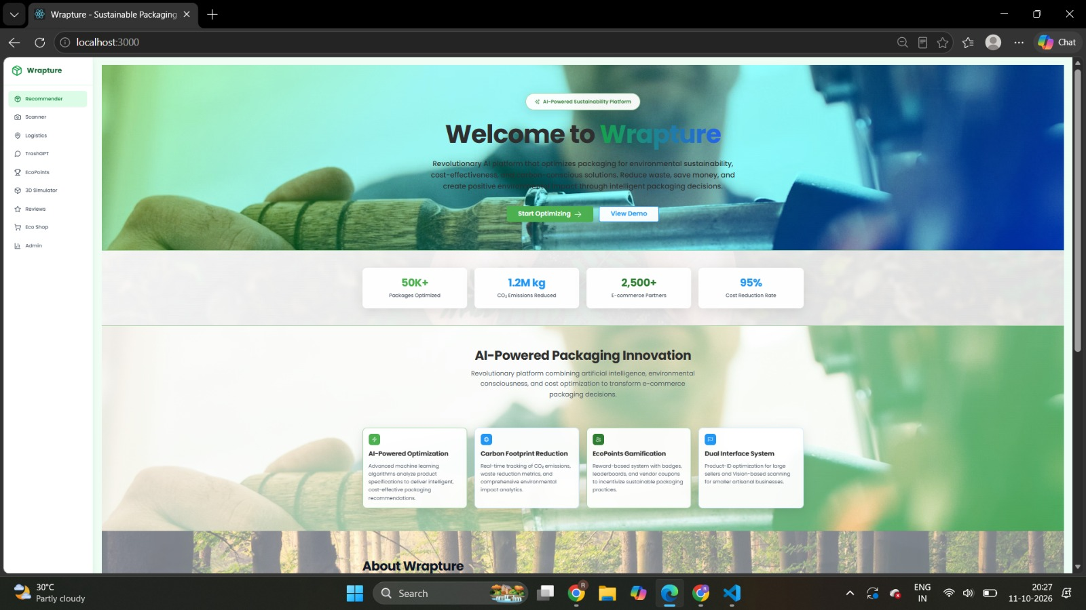
Figure 9.1: Wrapture Home Page
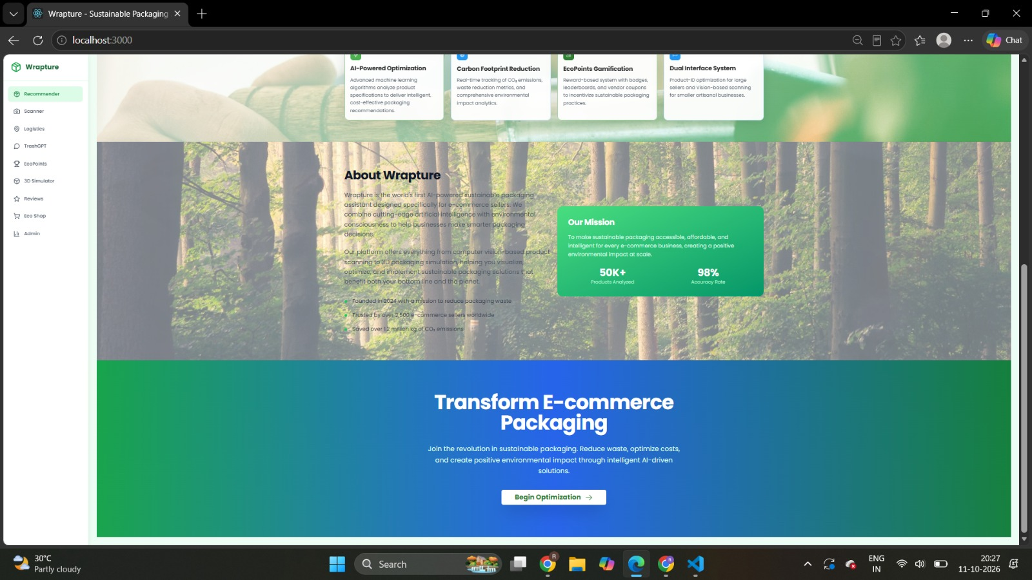
Figure 9.2: About Wrapture and Mission
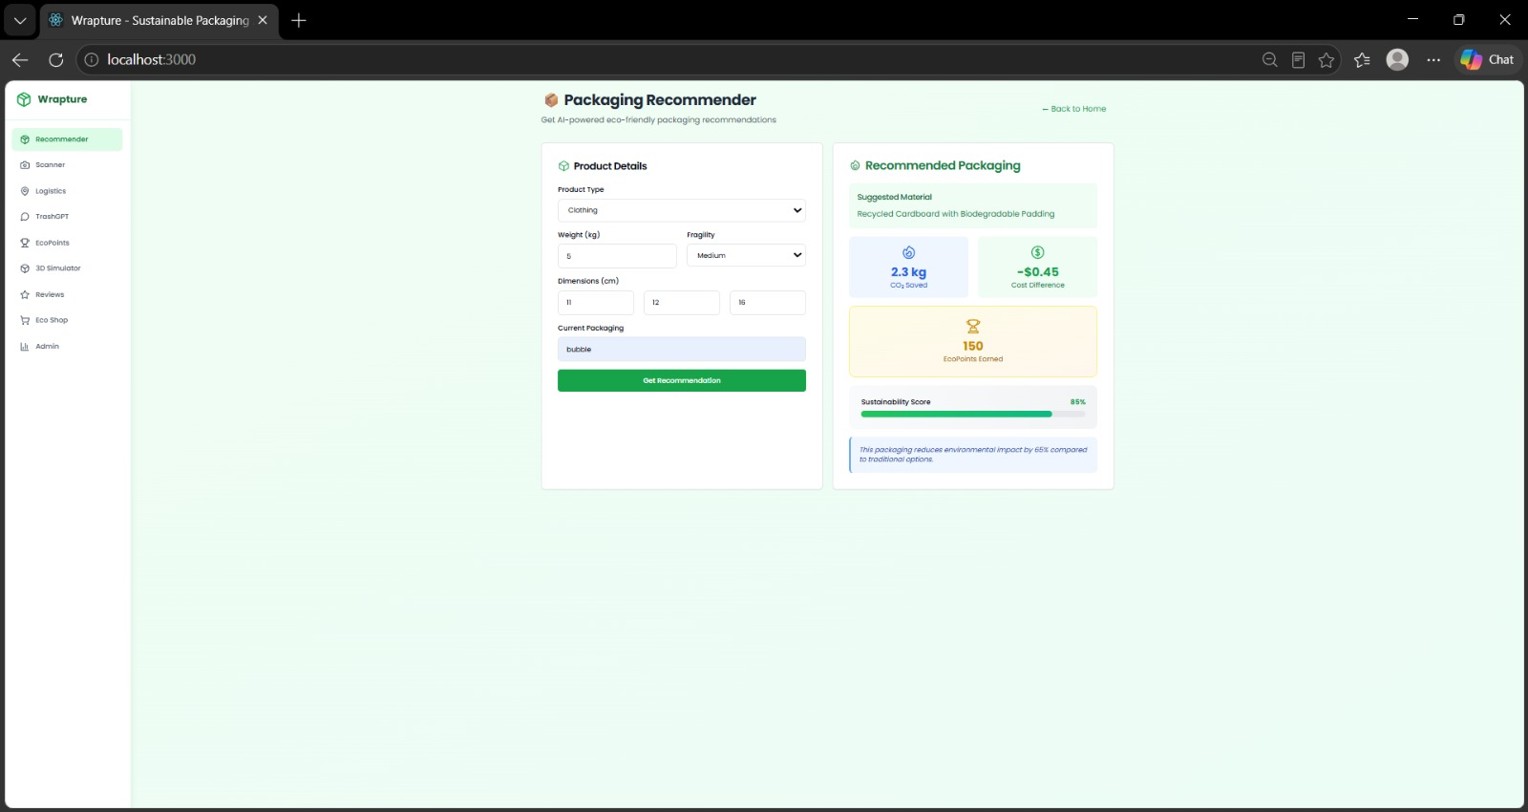
Figure 9.3: AI-Powered Packaging Recommender
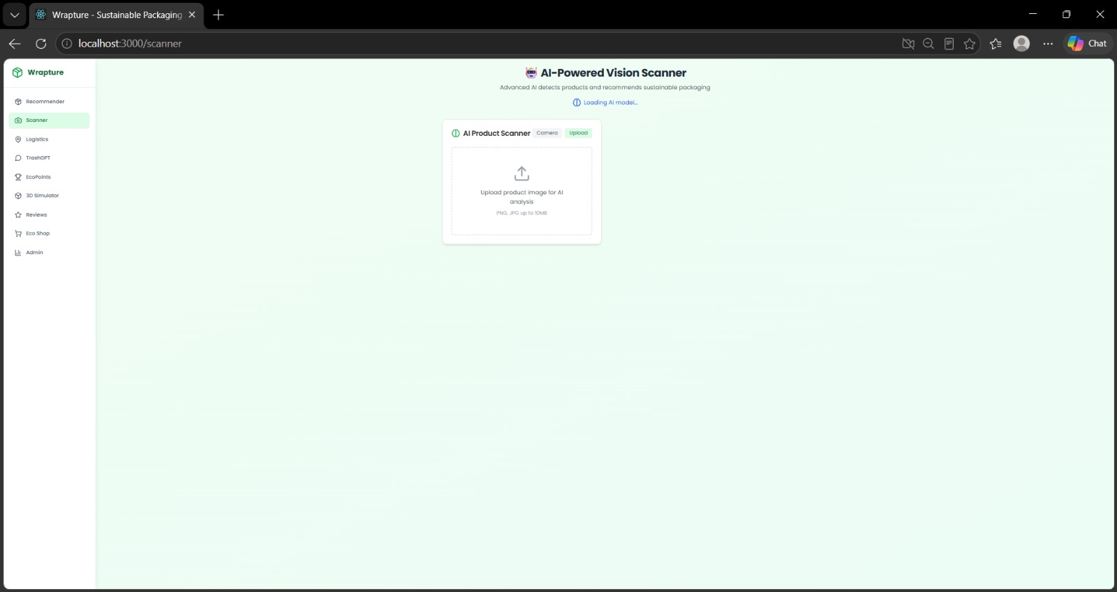
Figure 9.4: AI-Powered Vision Scanner
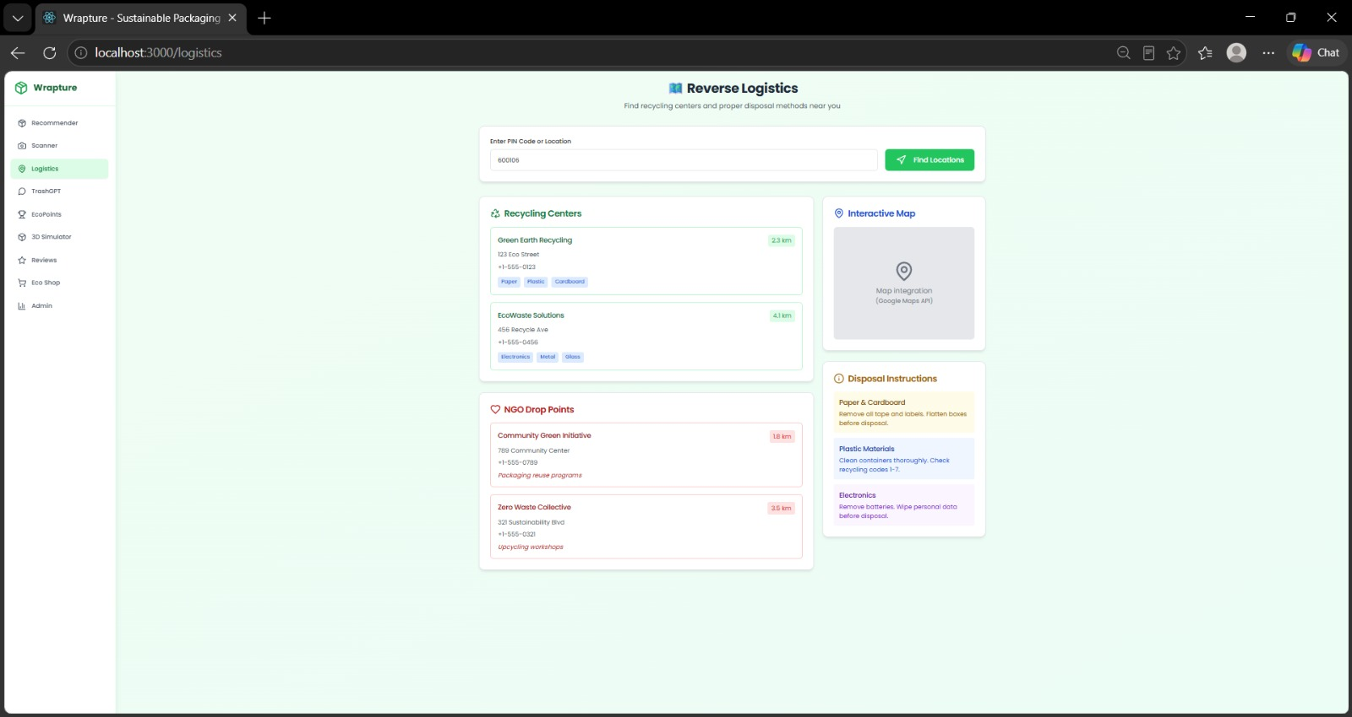
Figure 9.5: Reverse Logistics and Recycling Locator
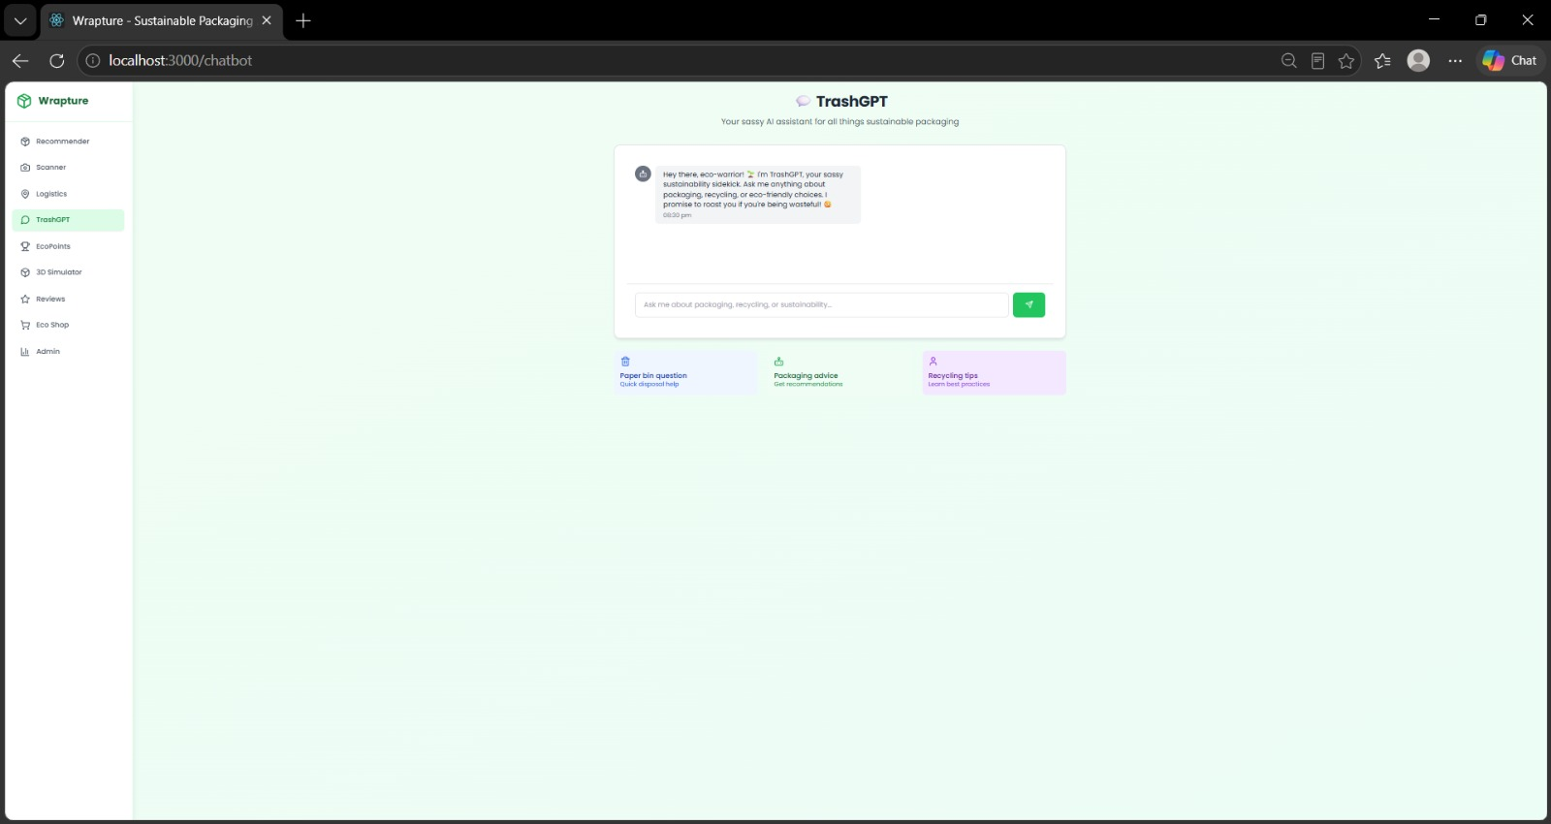
Figure 9.6: TrashGPT Sustainability Chatbot
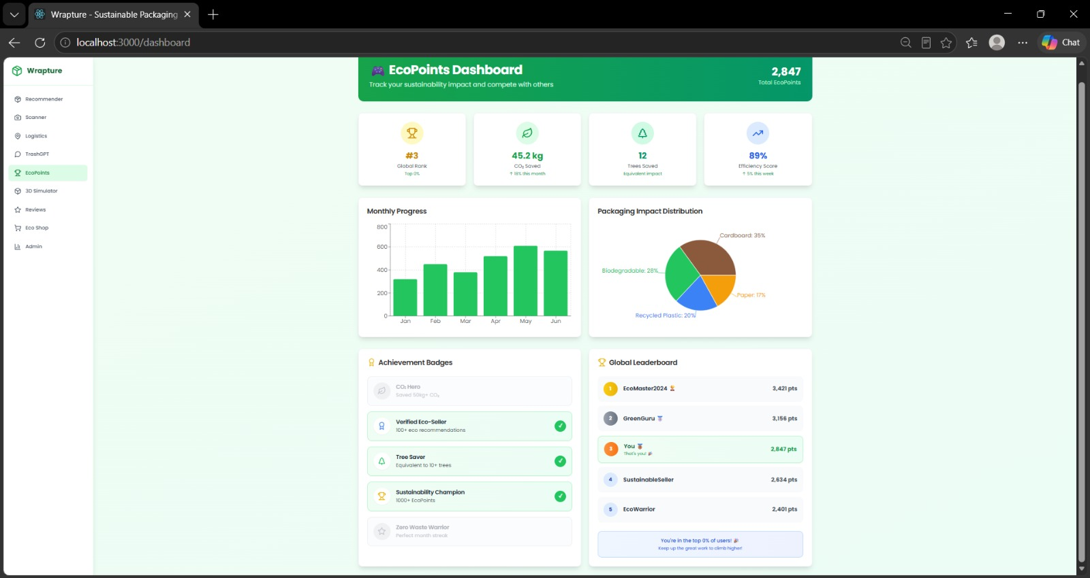
Figure 9.7: EcoPoints Dashboard
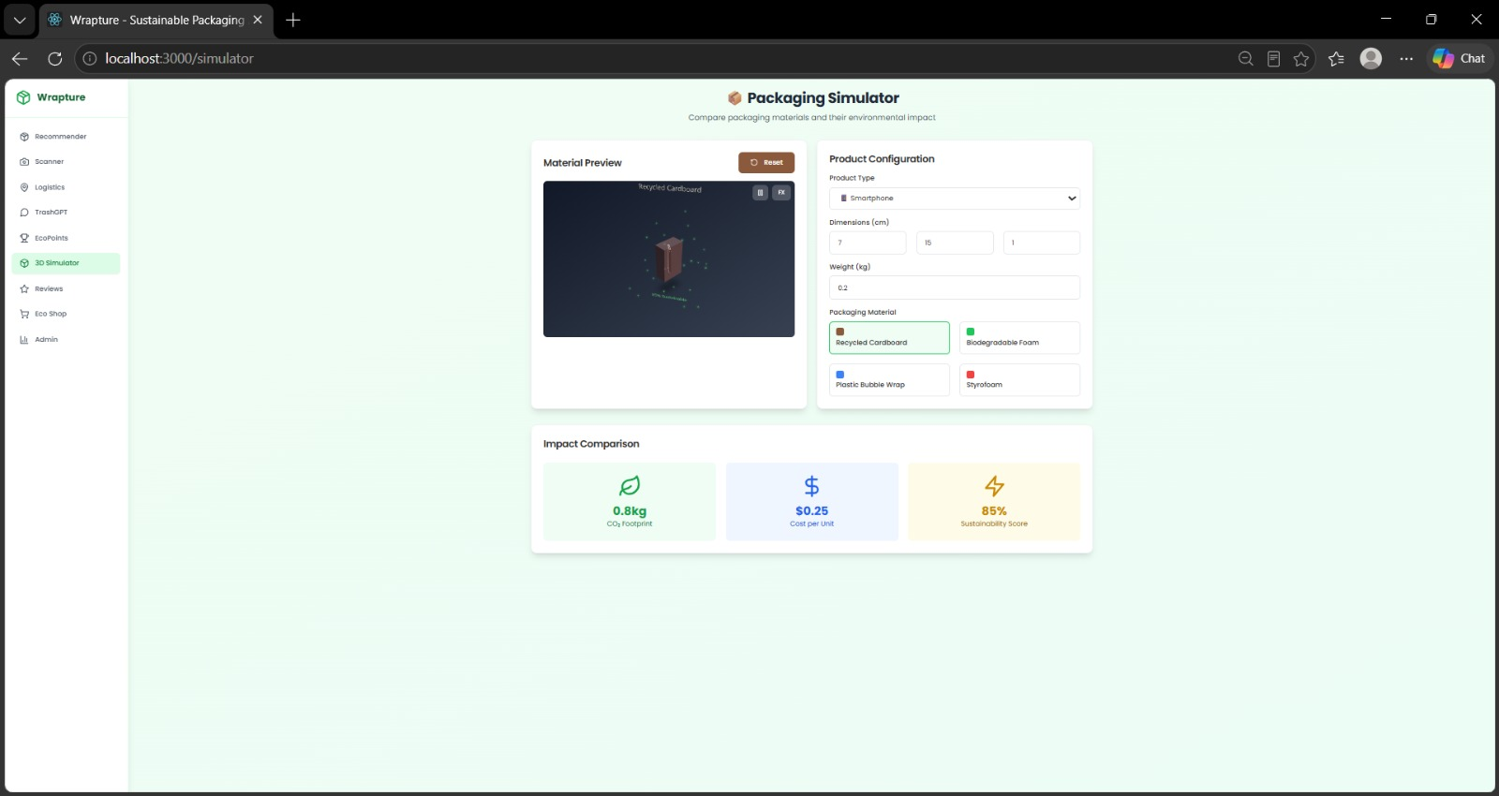
Figure 9.8: 3D Packaging Simulator
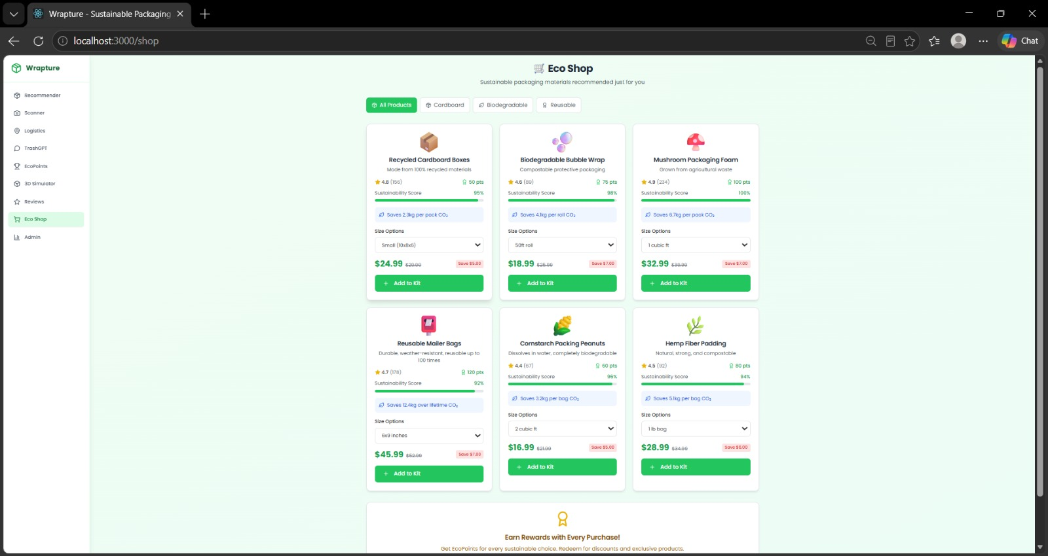
Figure 9.9: Eco Shop
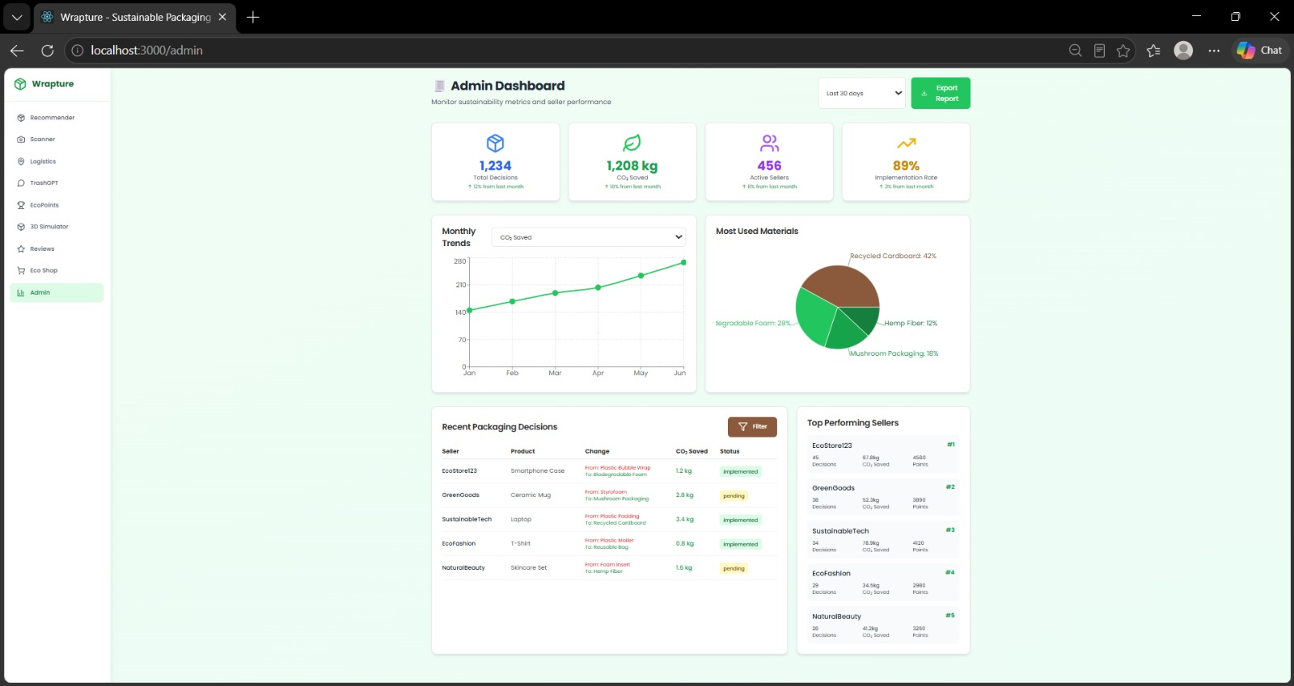
Figure 9.10: Admin Dashboard

Additional Testing Notes
Functional testing described in Chapter 5 was carried out manually on an Android device connected to the Flask backend over a local Wi-Fi network, with the backend URL set through the Server Configuration screen. The activity counters mentioned in Chapter 5 were read from the application's home screen.

CHAPTER 10
APPLIED CONFERENCE DETAILS


